**Array And Collection**

**1.Java Array In Depth**

**. Arrays in Java**

* An **array** is a collection of elements of the same data type, stored in contiguous memory locations.
* Arrays in Java are **objects**, meaning they are created dynamically at runtime.
* The size of an array is fixed once defined.
* Arrays are zero-indexed (the first element is at index 0).

**Corresponding Classes**

* Java arrays are part of the java.lang package and are internally represented as objects.
* They inherit directly from the Object class.

**2. One-Dimensional Array (1D Array)**

* A **1D array** is a linear collection of elements.

dataType[] arrayName = new dataType[size];

Example:

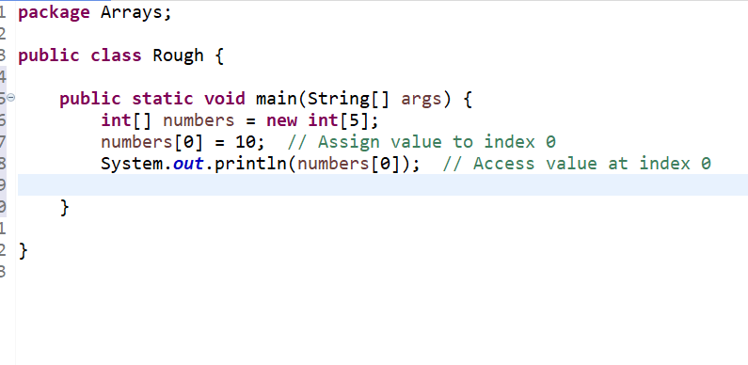

**Initialization**

int[] numbers = {1, 2, 3, 4, 5}; // Declare and initialize

Iteration:for (int i = 0; i < numbers.length; i++) {

System.out.println(numbers[i]);

}

**Key Points:**

* A 1D array is essentially a single row of elements.
* Can store data types like int, double, String, etc.

**Multidimensional Array**

A **multidimensional array** in Java is an array of arrays. Each array in the "parent" array can hold its own set of elements.

**Two-Dimensional Array (2D Array)**

A **2D array** is essentially a table (rows and columns).

**Example: int[][] matrix = new int[3][3];**

* The first 3 represents the **number of rows** in the array.
* The second 3 represents the **number of columns** in each row.
* Together, it creates a grid with 3 rows and 3 columns.
  + Total elements = 3 x 3 = 9

Here is how the structure looks:

Row 0: [0, 0, 0] // Default values

Row 1: [0, 0, 0]

Row 2: [0, 0, 0]

**Declaration and Initialization**

**1. Declaration and Initialization Using new:**

int[][] matrix = new int[3][3]; // Creates a 3x3 matrix

**Explanation:**

* This creates a 2D array with 3 rows and 3 columns.
* All elements are initialized to the default value of int, which is 0.

You can manually assign values like this:

matrix[0][0] = 1; // Set the value at row 0, column 0

matrix[1][1] = 5; // Set the value at row 1, column 1

matrix[2][2] = 9; // Set the value at row 2, column 2

2. Declaration and Direct Initialization:

int[][] matrix = {

{1, 2, 3}, // Row 0

{4, 5, 6}, // Row 1

{7, 8, 9} // Row 2

};

**Explanation:**

* This directly initializes the array with the specified values.
* The structure looks like this

Row 0: [1, 2, 3]

Row 1: [4, 5, 6]

Row 2: [7, 8, 9]

You can access elements using their **row index** and **column index**:

System.out.println(matrix[0][0]); // Output: 1 (Row 0, Column 0)

System.out.println(matrix[1][2]); // Output: 6 (Row 1, Column 2)

**Iterating Over a 2D Array**

**Nested Loops**

To iterate over rows and columns:

for (int i = 0; i < matrix.length; i++) { // Outer loop for rows

for (int j = 0; j < matrix[i].length; j++) { // Inner loop for columns

System.out.print(matrix[i][j] + " ");

}

System.out.println(); // Move to the next line after each row

}

Output for the matrix above:

1 2 3

4 5 6

7 8 9

**Jagged Arrays (Irregular 2D Arrays)**

Unlike a standard 2D array, where all rows have the same number of columns, **jagged arrays** allow rows to have different lengths.

**Example:**

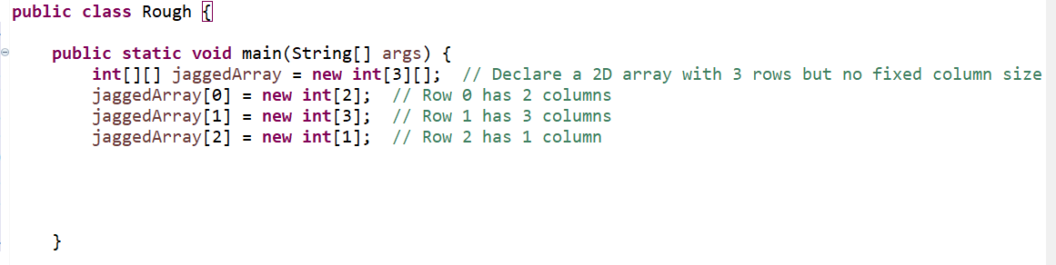

**Structure:**

Row 0: [0, 0]

Row 1: [0, 0, 0]

Row 2: [0]

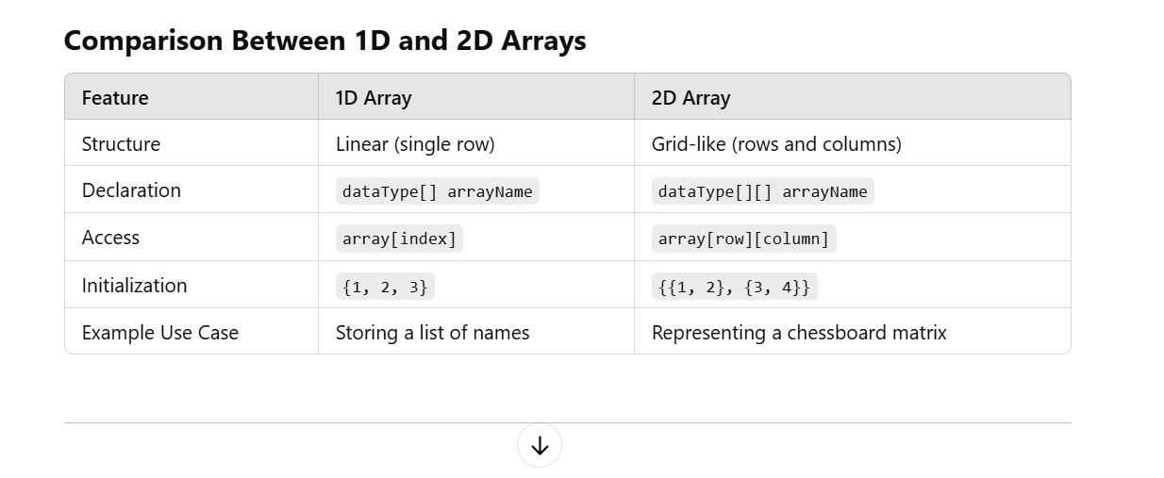

**Key Notes**

1. Use a **2D array** for data structured in rows and columns (like matrices, tables, or grids).
2. Remember that the first index is the row and the second index is the column in a 2D array.
3. For irregular row sizes, consider using **jagged arrays**.

**2.Difference Between Collection and Collections**

**Collection:**

* **Definition**: It is an **interface** in the java.util package.
* **Purpose**: Represents a group of objects known as elements.
* **Part of**: Java Collections Framework.
* **Key Subinterfaces**:
  + List
  + Set
  + Queue
* **Examples**:
  + ArrayList, HashSet, PriorityQueue implement Collection.

**Collections:**

* **Definition**: It is a **utility class** in the java.util package.
* **Purpose**: Provides static methods to operate on or return collections.
* **Key Methods**:
  + Sorting: Collections.sort(list)
  + Searching: Collections.binarySearch(list, key)
  + Synchronization: Collections.synchronizedList(list)
  + Minimum and Maximum: Collections.min(collection), Collections.max(collection)
* **Not Part of**: The Collection interface.

**2. Overview of the Collection Framework Architecture**

**What is the Collection Framework?**

* A **framework** that provides a standard way to organize, manipulate, and store groups of objects in Java.
* **Key Features**:
  + Interfaces: Define the abstract types.
  + Implementations: Provide concrete classes like ArrayList, HashSet.
  + Algorithms: Utilities for sorting, searching, etc.

**Diagram of the Collection Framework**

Here’s the simplified hierarchy:

sql

Copy code

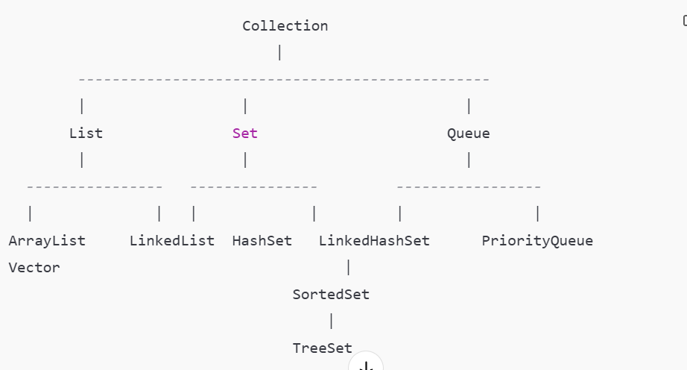

**Key Interfaces in Collection Framework**

1. **Collection**: Root interface for all collections.
2. **List**: Ordered collection (allows duplicates). Example: ArrayList, LinkedList.
3. **Set**: Unordered collection (no duplicates). Example: HashSet, TreeSet.
4. **Queue**: Collection for holding elements to process in FIFO order. Example: PriorityQueue.
5. **Map**: Maps keys to values (not derived from Collection interface). Example: HashMap.

**2.** **List in Java**

A **List** in Java is an **interface** in the java.util package that is part of the **Java Collections Framework**. It represents an **ordered collection** of elements, where duplicates are allowed, and elements can be accessed using an **index**.

**Key Features of List**

1. **Order**:
   * The elements in a List are stored in the **insertion order**.
   * You can rely on the order in which elements are added to the list.
2. **Duplicates Allowed**:
   * A List can contain duplicate elements.
3. **Index-Based Access**:
   * Elements can be accessed, modified, or removed using their **index** (position in the list).
4. **Dynamic Resizing**:
   * Unlike arrays, most List implementations (e.g., ArrayList) grow dynamically as elements are added.

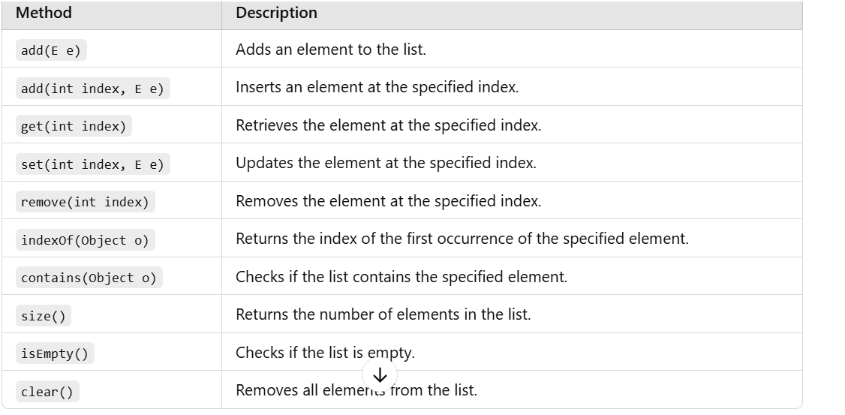

**List.of() and Immutability**

**What is List.of()?**

* List.of() is a static factory method introduced in **Java 9** to create immutable lists.
* The list created using List.of() is **unmodifiable** and does **not allow null elements**.

**Example**

List<String> words = List.of("a", "b", "c");

System.out.println(words); // Output: [a, b, c]

**Key Characteristics**

1. **Immutability**:
   * Once the list is created, you **cannot modify it** (add, remove, or update elements).

words.add("d"); // Throws UnsupportedOperationException

words.remove("a"); // Throws UnsupportedOperationException

words.set(0, "z"); // Throws UnsupportedOperationException

**No Nulls Allowed**:

* Adding null as an element will throw a NullPointerException.

List<String> invalidList = List.of("a", null); // Throws NullPointerException

**Fixed Size**:

* The size of the list is fixed and cannot be changed.

**When to Use?**

* Use List.of() when you need a **read-only** list, especially for constants or configuration values.

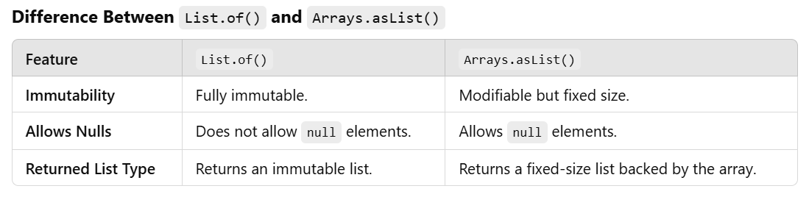

**3. Detailed Explanation of ArrayList**

**What is ArrayList?**

* A **class** in the java.util package.
* Implements the List interface.
* Allows dynamic resizing, unlike arrays (fixed size).
* Stores **elements in insertion order** and allows duplicates.

**Features of ArrayList**

1. **Dynamic Resizing**:
   * Automatically increases its size when elements are added beyond its current capacity.
2. **Indexed Access**:
   * Elements can be accessed using indices, making it faster for read operations.
3. **Allows Null**:
   * null values can be stored.
4. **Non-Synchronized**:
   * Not thread-safe; requires external synchronization for concurrent access.

**Constructors of ArrayList**

1. **Default Constructor**:

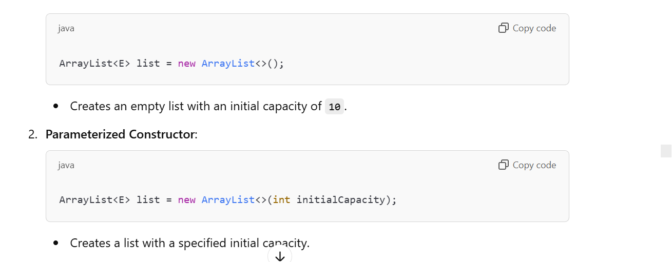

1. **Collection Constructor**:

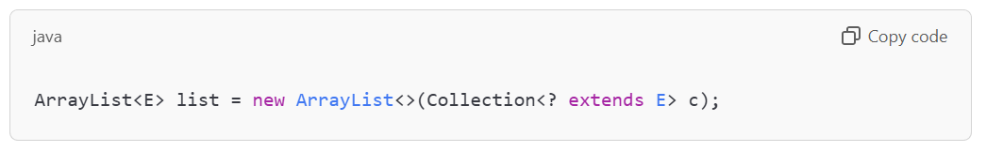

Creates a list containing elements of a specified collection.

**Methods in ArrayList**

1. **Adding Elements**:

list.add("Element"); // Appends at the end

list.add(2, "Indexed"); // Inserts at index 2

1. **Removing Elements**:

list.remove("Element"); // Removes first occurrence

list.remove(1); // Removes element at index 1

1. **Accessing Elements**:

String element = list.get(0); // Access by index

1. **Updating Elements**:

list.set(0, "New Value"); // Update element at index 0

1. **Checking Size**:

int size = list.size(); // Returns the number of elements

1. **Iterating**:

for (String item : list) {

System.out.println(item);

}

**Example:**

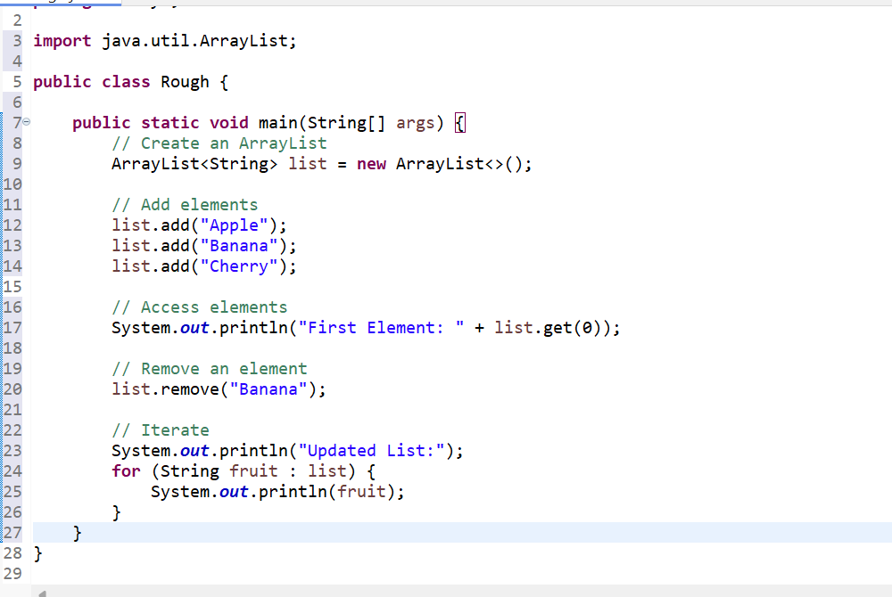

**Advantages of ArrayList**

1. **Dynamic Resizing**: Automatically grows as elements are added.
2. **Indexed Access**: Provides fast random access.
3. **Flexibility**: Allows insertion, deletion, and iteration.

**Disadvantages of ArrayList**

1. **Performance**: Slower compared to arrays for operations like searching.
2. **Not Synchronized**: Requires manual synchronization in multi-threaded environments.

**Interview Questions**

1. **What is the difference between Array and ArrayList?**
   * **Array** is fixed-size; **ArrayList** is dynamic.
   * Array can store primitive data types; ArrayList stores objects.
2. **How does ArrayList grow dynamically?**
   * When the current capacity is exceeded, ArrayList creates a new array with 50% more capacity and copies the old elements to the new array.
3. **Is ArrayList thread-safe?**
   * No, ArrayList is not synchronized. Use Collections.synchronizedList() or CopyOnWriteArrayList for thread safety.
4. **How to synchronize an ArrayList?**

List<String> synchronizedList = Collections.synchronizedList(new ArrayList<>());

**Code Explanation**

1. **Collections.synchronizedList**:
   * Converts a regular ArrayList into a thread-safe list.
   * Synchronization ensures that multiple threads accessing or modifying the list won't cause data corruption.

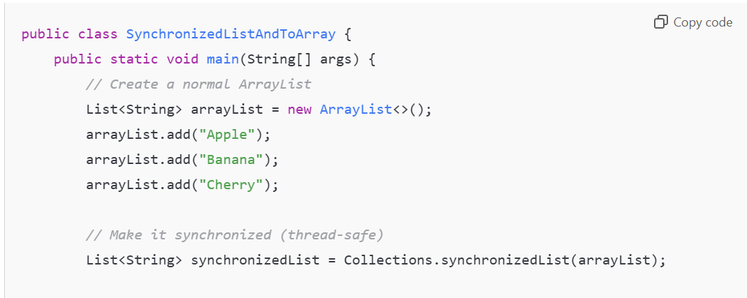

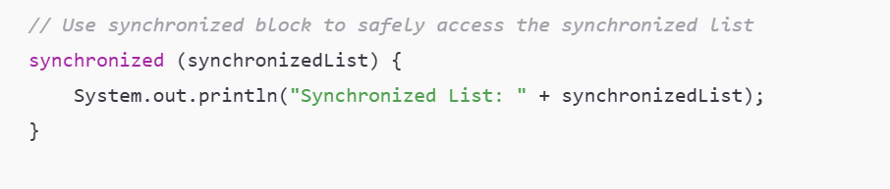

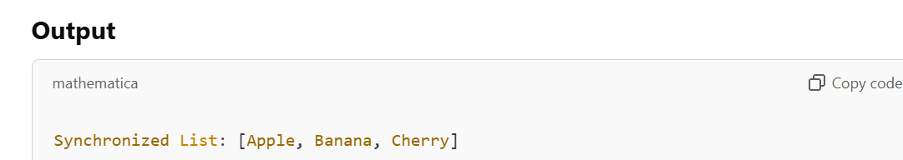

1. **What is the initial capacity of ArrayList?**

* Default capacity is 10.

1. **How to convert ArrayList to an array?**

String[] array = list.toArray(new String[0]);

**Code Explanation**

**list.toArray(new String[0])**:

* Converts a List<String> to an array of String objects.
* The new String[0] ensures the correct type of array is returned

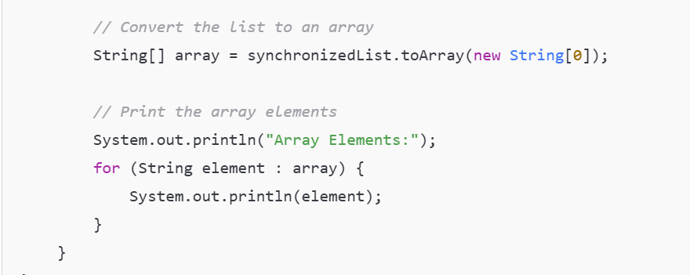

0/p

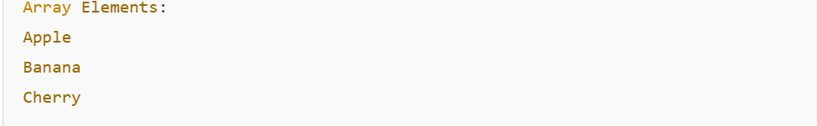

1. **What happens when you add null to an ArrayList?**

* null can be added, and it behaves like any other object.

**Interfaces Implemented by ArrayList**

The ArrayList class implements several interfaces, each contributing to its behavior. Here's a detailed breakdown:

**1. List**

* **Description**:
  + ArrayList implements the List interface, which represents an **ordered collection** of elements.
  + It allows:
    - Duplicate elements.
    - Access by index.
    - Insertion of elements at specific positions.
* **Key Methods from List Interface**:
  + add(E e): Adds an element to the list.
  + add(int index, E element): Inserts an element at a specific position.
  + get(int index): Returns the element at the specified index.
  + remove(int index): Removes the element at the specified index.

**2. RandomAccess**

* **Description**:
  + This is a **marker interface** used to indicate that the list supports fast (constant-time) random access.
  + ArrayList implements this because it allows direct access to elements using their index.
* **Purpose**:
  + Enhances performance for scenarios where random access (e.g., get(index)) is frequently used.

**3. Cloneable**

* **Description**:
  + Indicates that the class supports cloning, meaning it can create a **shallow copy** of the ArrayList.
  + The clone() method creates a new ArrayList object with the same elements.
* **Usage**:

java

Copy code

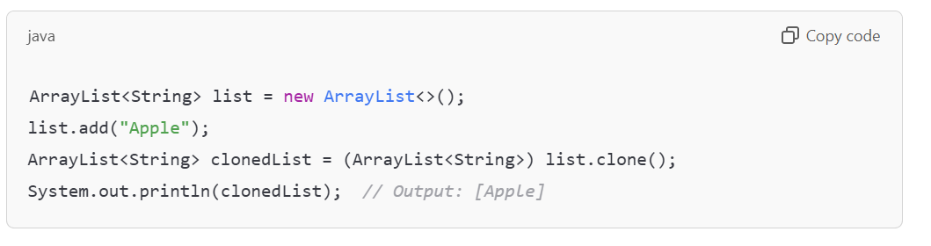

**Serializable**

* **Description**:
  + Enables ArrayList objects to be serialized, meaning their state can be saved to a file or transferred over a network.
  + Required for persistence or communication purposes.
* **Usage**:
  + Serialization can be done using ObjectOutputStream and deserialization using ObjectInputStream.
  + Example:

java

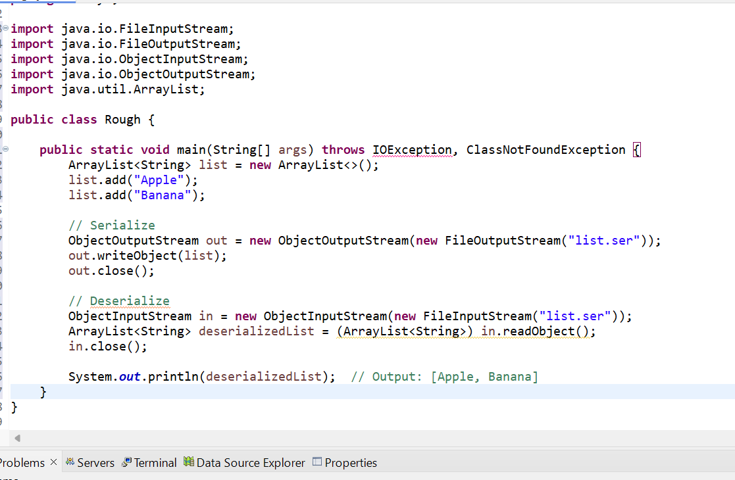

4.**LinkedList in Java**

The LinkedList class in Java is part of the java.util package and implements the **List**, **Deque**, and **Queue** interfaces. It represents a doubly linked list, where each node contains:

1. A reference to the previous node.
2. A reference to the next node.
3. The data.

**Key Characteristics of LinkedList**

1. **Dynamic Size**:
   * The size of a LinkedList can dynamically grow or shrink during runtime.
2. **Efficient Insertions/Deletions**:
   * Inserting or removing elements from the middle or ends of a LinkedList is faster compared to an ArrayList because it doesn’t involve shifting elements.
3. **Non-Contiguous Storage**:
   * Elements are stored in **nodes** that are linked using pointers/references, unlike ArrayList where elements are stored in contiguous memory.

In **ArrayList**, elements are stored in **contiguous memory** (one after another in a single block). For example, an ArrayList of size 5 would look like this in memory:

[Element1] [Element2] [Element3] [Element4] [Element5]

* In **LinkedList**, elements are stored in **nodes**, and each node contains:
  1. **Data**: The actual value stored.
  2. **Pointers/References**:
     + One pointer to the previous node.
     + One pointer to the next node.
  3. The nodes are scattered in memory but linked together using these pointers.

**Structure of LinkedList**

For example, a LinkedList storing "A", "B", "C" might look like this in memory:

[Null <- A -> Address1] -> [Address0 <- B -> Address2] -> [Address1 <- C -> Null]

Here:

* Each node points to the previous node (<-) and the next node (->).
* Nodes are **not contiguous** (not stored next to each other).
* **Contiguous memory** means all elements are stored in a continuous block of memory locations.
* If the array runs out of space, a new array with a larger size is created, and all elements are copied to the new array (which is expensive).

1. **Implements Deque and Queue**:
   * Can be used as a **FIFO (First In, First Out)** or **LIFO (Last In, First Out)** queue.

**What is Deque?**

* **Deque** stands for **Double-Ended Queue**.
* It allows adding and removing elements from **both ends** of the list.
* A LinkedList implements the Deque interface, so it can function as:
  + **FIFO (First In, First Out)**: Like a **Queue**.
  + **LIFO (Last In, First Out)**: Like a **Stack**.

**LinkedList as a Queue (FIFO)**

* **FIFO (First In, First Out)** means elements are processed in the order they are added (like a line at a ticket counter).
* LinkedList provides methods to act as a queue:
  + addLast(E e): Add elements at the **end** of the queue.
  + removeFirst(): Remove elements from the **start** of the queue.

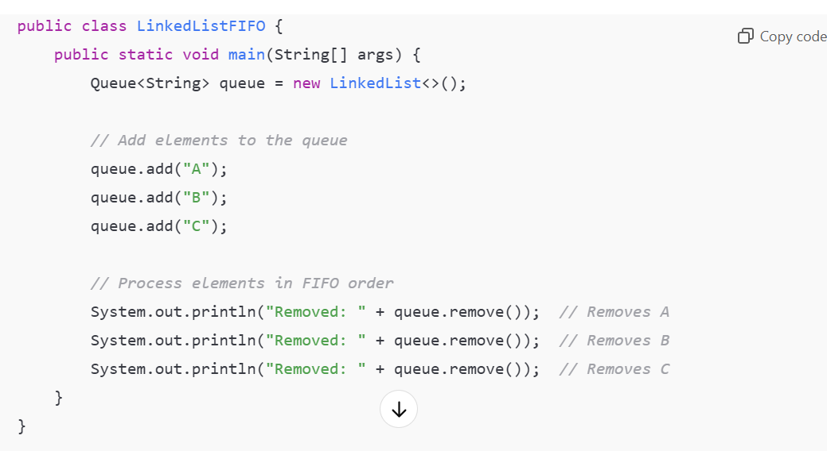

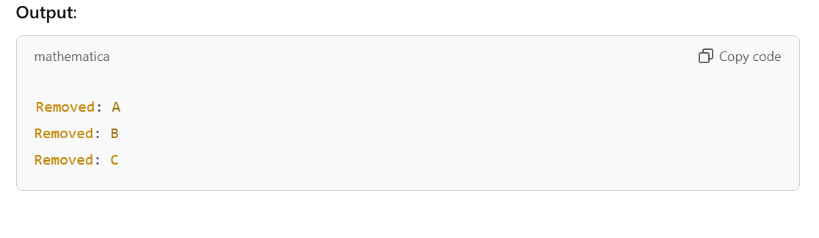

**LinkedList as a Stack (LIFO)**

* **LIFO (Last In, First Out)** means the last element added is the first to be removed (like stacking plates).
* LinkedList provides methods to act as a stack:
  + addFirst(E e): Add elements at the **beginning** of the stack.
  + removeFirst(): Remove elements from the **beginning** of the stack.

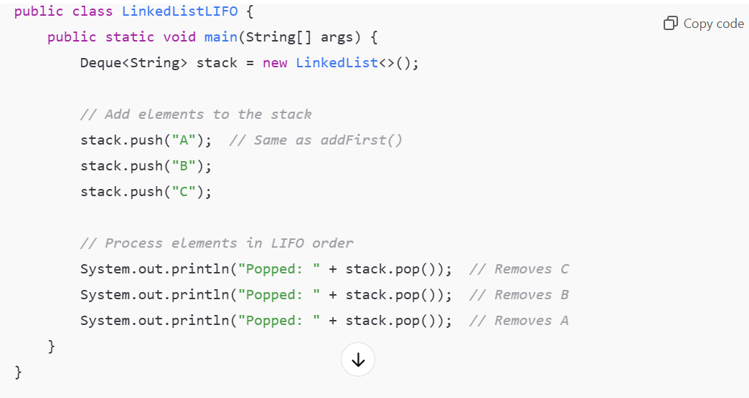

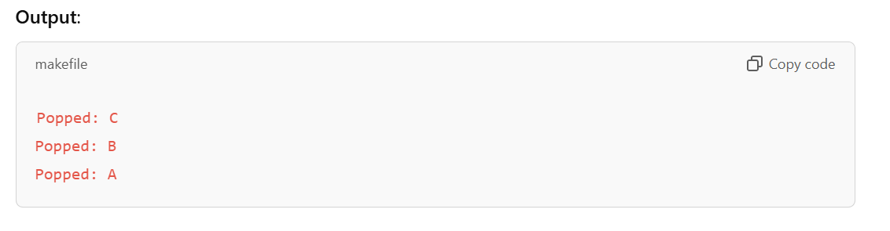

**Constructors**

1. **Default Constructor**:

LinkedList<E> list = new LinkedList<>();

Creates an empty linked list.

1. **Collection Constructor**:

LinkedList<E> list = new LinkedList<>(Collection<? extends E> c);

Creates a linked list containing the elements of the given collection.

**Key Methods of LinkedList**

**Basic Operations**

1. **Add Elements**:

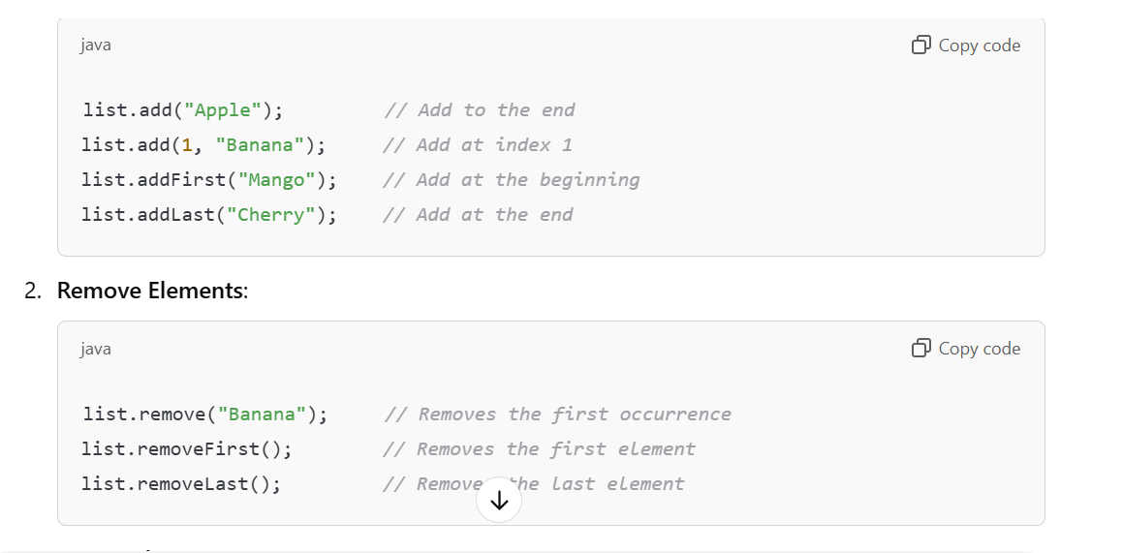

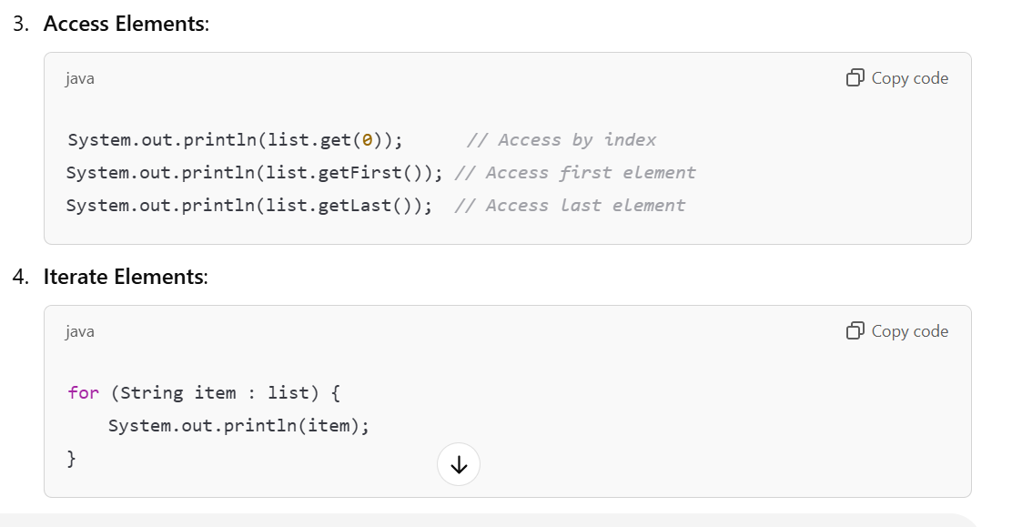

**Examples**

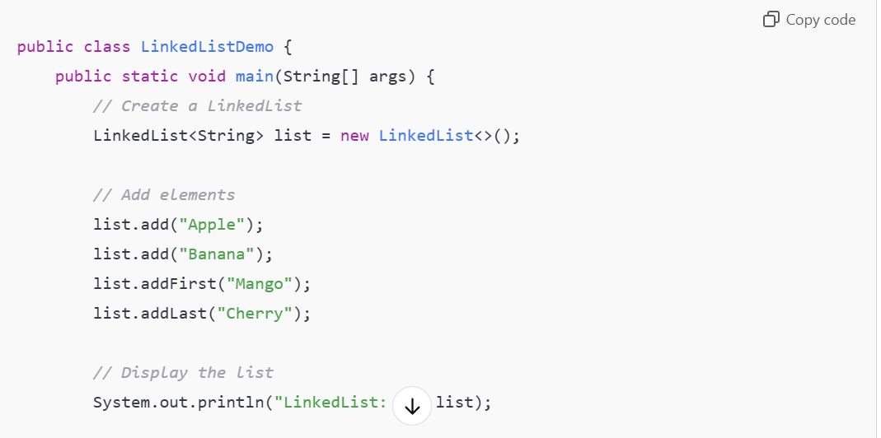

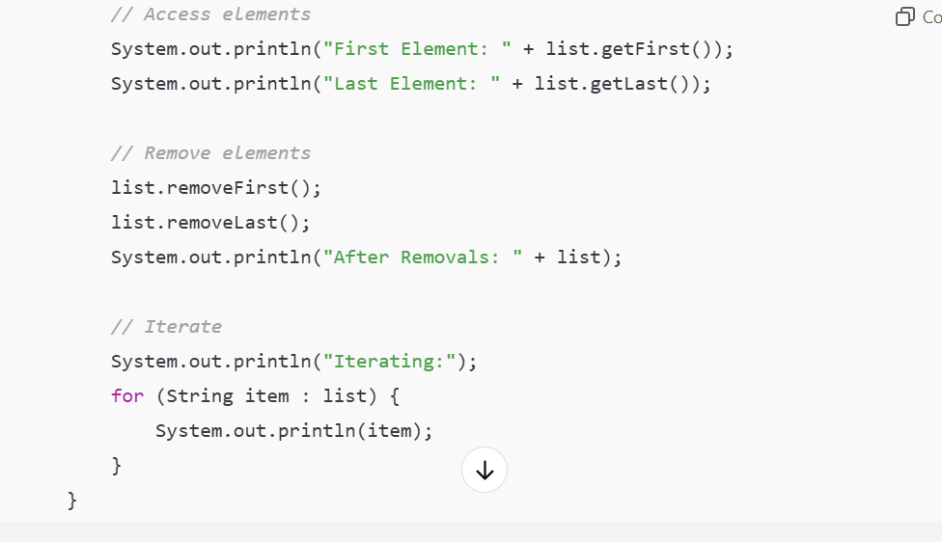

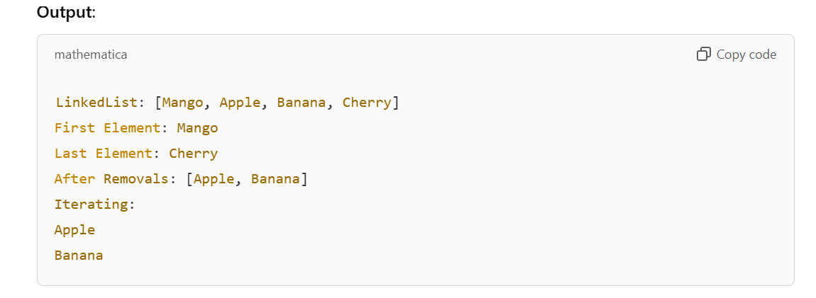

**Advantages of LinkedList**

1. **Efficient Insertions and Deletions**:
   * Inserting or deleting elements is faster as no shifting is required.
2. **Flexible Storage**:
   * Can grow or shrink dynamically without resizing overhead.
3. **Efficient for Queue Operations**:
   * Adding/removing from the beginning or end is efficient.

**Disadvantages of LinkedList**

1. **Slow Access Time**:
   * Accessing an element by index (get(index)) takes **O(n)** time because traversal is required.
2. **Memory Overhead**:
   * Each node requires extra memory for pointers to the previous and next nodes.
3. **Not Cache-Friendly**:
   * Elements are not stored in contiguous memory, making it slower compared to ArrayList for traversal.

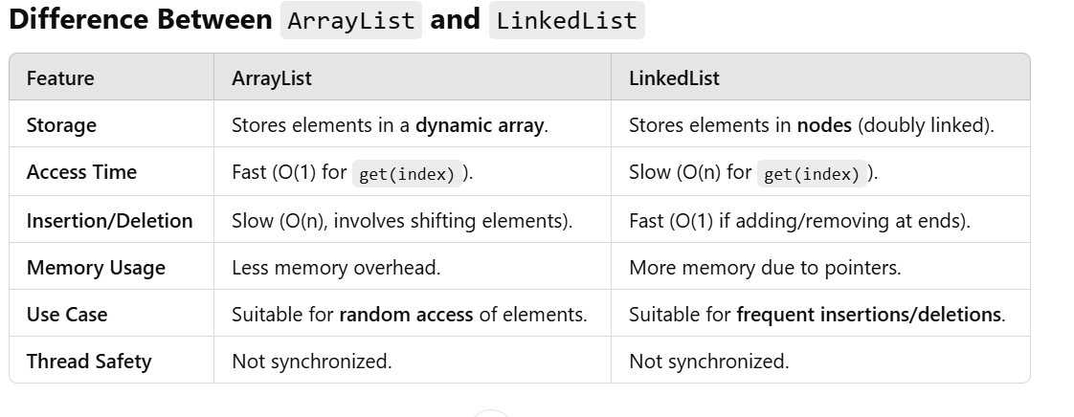

**When to Use LinkedList?**

* When frequent insertions or deletions are required in the middle of a collection.
* When you need a **FIFO (Queue)** or **LIFO (Deque/Stack)** data structure.
* When memory allocation is not a concern.

**When to Avoid LinkedList?**

* When frequent random access (via indices) is required.
* When memory usage is a constraint.
* For small datasets where the overhead of pointers is unnecessary.

**Interview Questions on LinkedList**

1. **What is the difference between ArrayList and LinkedList?**
   * Refer to the comparison table above.
2. **What is the time complexity of operations in LinkedList?**
   * Insertion/Deletion (at the ends): **O(1)**.
   * Insertion/Deletion (in the middle): **O(n)**.
   * Access (by index): **O(n)**.
3. **Can a LinkedList contain null values?**
   * Yes, LinkedList allows null values.
4. **Why is LinkedList not cache-friendly?**
   * Elements are scattered in memory, making it less efficient for traversals.
5. **Does LinkedList allow duplicate elements?**
   * Yes, it allows duplicates like other List implementations.
6. **How does a LinkedList grow dynamically?**
   * Nodes are created dynamically as elements are added, without resizing.
7. **How can you synchronize a LinkedList?**

List<String> synchronizedLinkedList = Collections.synchronizedList(new LinkedList<>());

1. **Which is better for implementing a stack or queue: ArrayList or LinkedList?**

* LinkedList is better for stacks (LIFO) and queues (FIFO) because of its efficient addition/removal at ends.
* **Java Collections Sorting: Lists and ArrayLists**
* **1. Basic List Sorting**
* Java Collections framework provides methods to sort lists, but there are rules that must be followed when sorting objects.
* **Example: Sorting Lists of Primitive Types**
* For built-in types like Integer, sorting works directly because these classes already implement the Comparable interface:

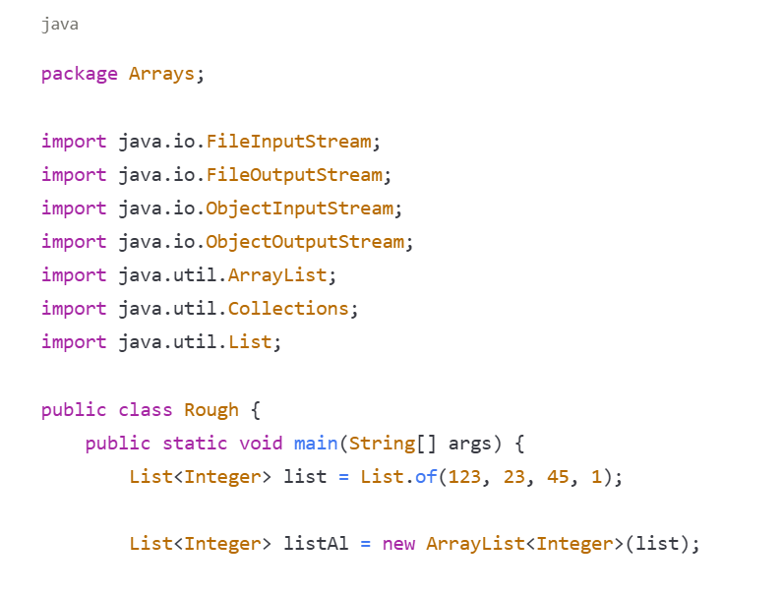

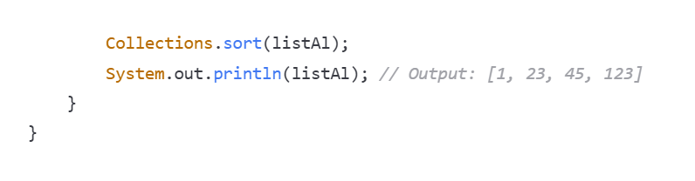

**Common Sorting Methods Error**

When trying to use the sort() method directly on a List, you might encounter errors:

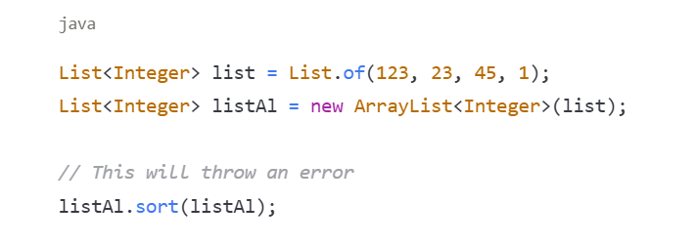

This produces a compilation error:

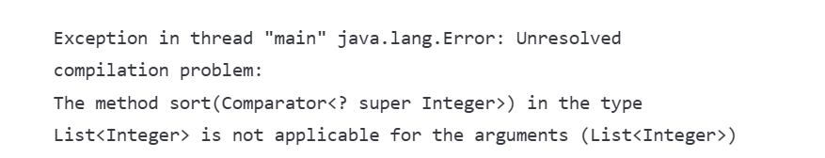

The error occurs because the sort() method of List expects a Comparator as an argument, not the list itself.

**Direct Sorting Attempt with Custom Objects (Will Throw Exception)**

When we try to sort a list of custom objects directly without implementing proper sorting mechanisms:

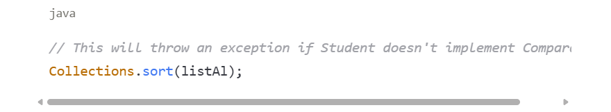

The exception occurs because Java doesn't know how to compare the objects in the list.

**Proper Way to Sort**

To properly sort collections, we have two main approaches:

1. Make the class implement the Comparable interface
2. Use a custom Comparator

For built-in types like Integer, String, etc., which already implement Comparable:

* Use Collections.sort(list) - This works without additional parameters
* Use list.sort(null) - Passing null as the comparator parameter uses the natural ordering

**2. Creating a Sortable Class**

Let's look at our Student class example:

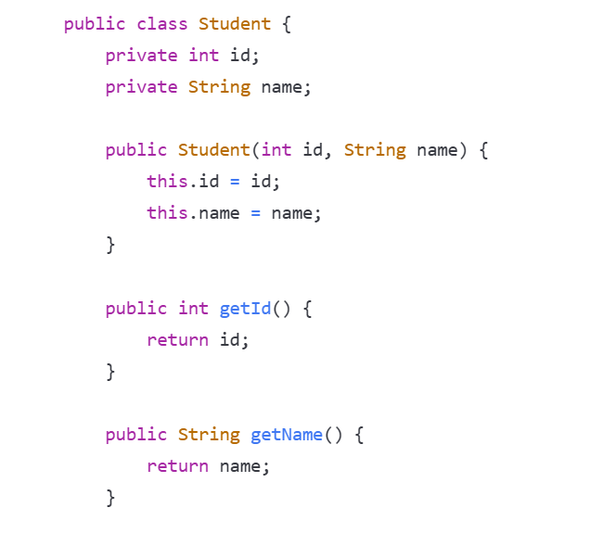

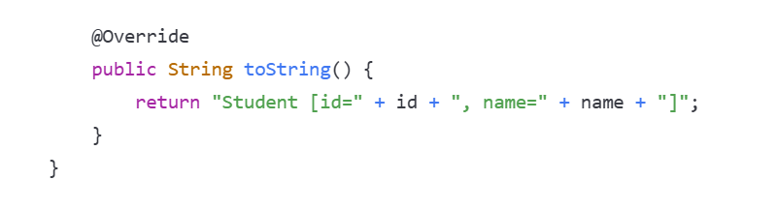

**3. Approach 1: Implementing Comparable Interface**

To enable natural ordering, make the class implement Comparable:

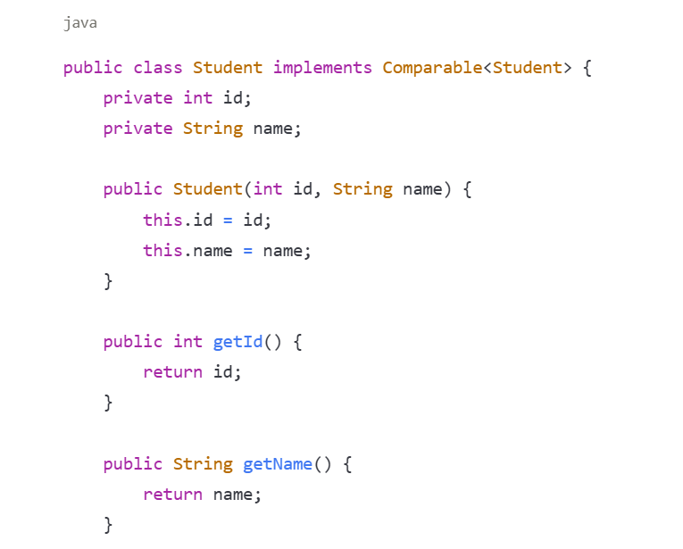

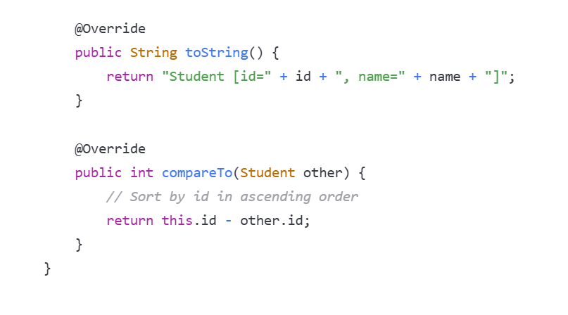

**Key Points About compareTo Method:**

* Returns a negative integer if this object is less than the other
* Returns zero if this object equals the other
* Returns a positive integer if this object is greater than the other

With this implementation, we can now sort a list of Student objects:

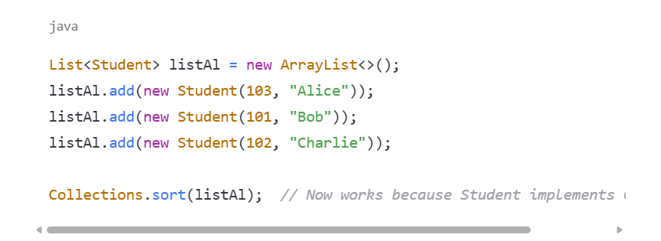

**4. Approach 2: Using Custom Comparators**

Instead of modifying the student class, we can create separate comparator classes to define different sorting strategies.

**ID-Based Sorting Comparator:**

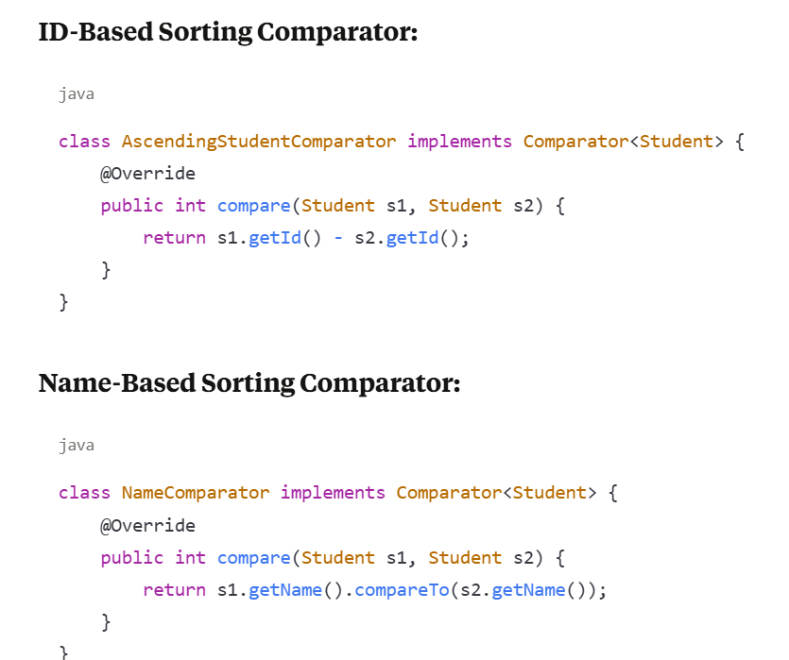

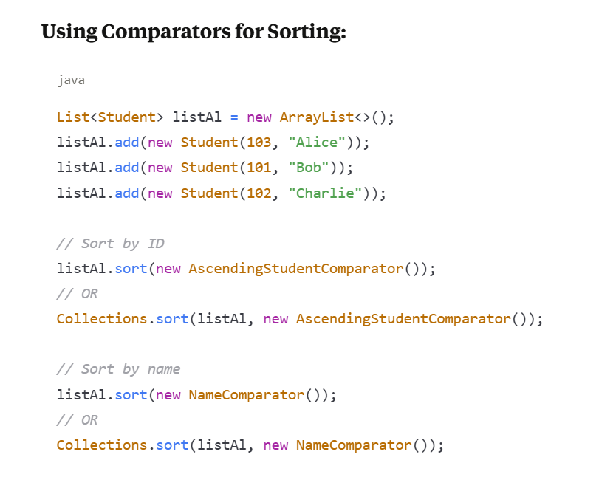

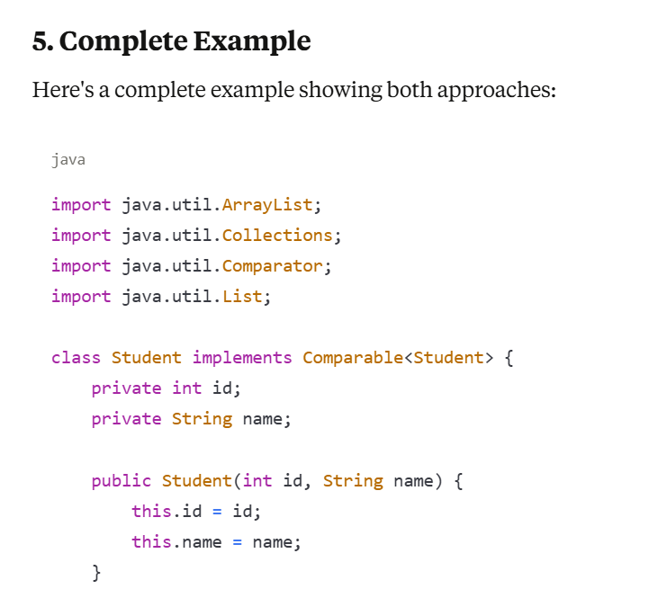

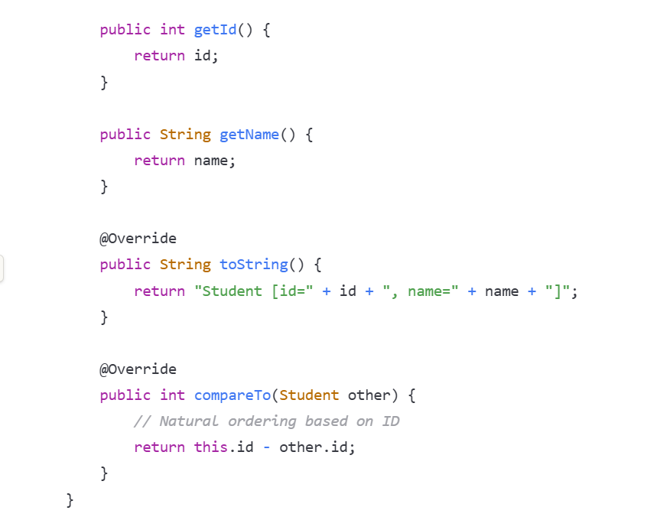

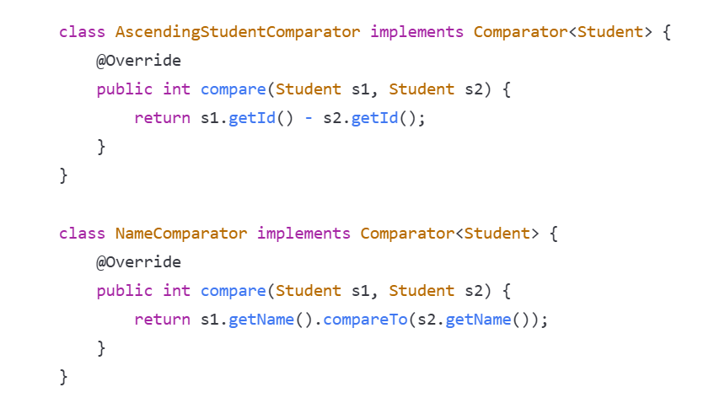

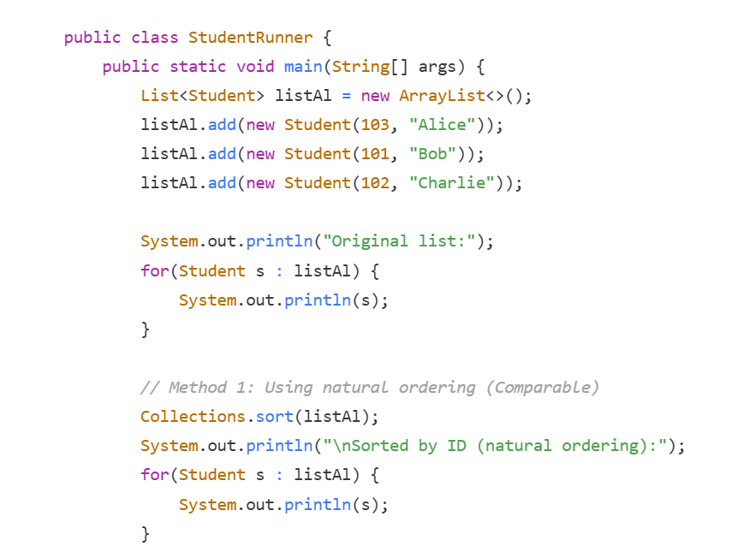

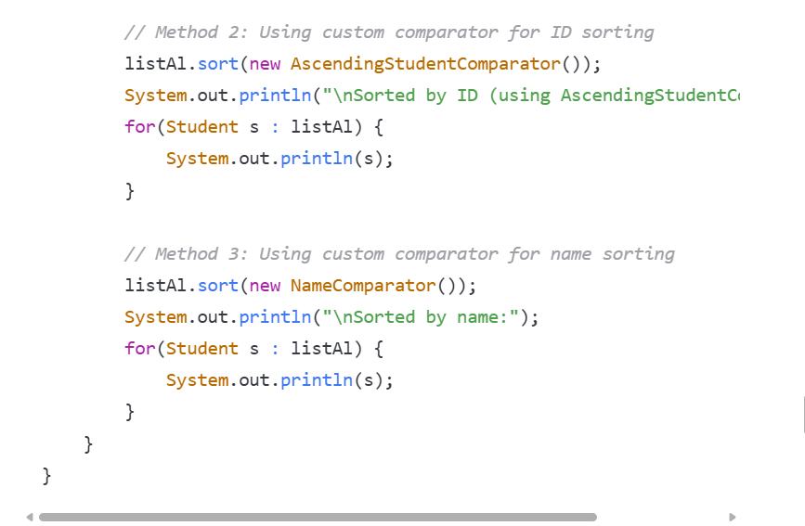

**6. Summary**

**Two Approaches to Sorting in Java:**

1. **Implementing Comparable (Natural Ordering)**
   * Modify the class itself to implement Comparable<T>
   * Override the compareTo(T other) method
   * This defines the "natural ordering" of the objects
   * Use Collections.sort(list) without additional parameters
2. **Using Comparator (Custom Ordering)**
   * Create separate classes implementing Comparator<T>
   * Override the compare(T o1, T o2) method
   * Allows multiple different sorting strategies without modifying the original class
   * Use list.sort(comparator) or Collections.sort(list, comparator)

**When to Use Each Approach:**

* Use **Comparable** when there's a clear, default way to sort the objects
* Use **Comparator** when:
  + You want multiple ways to sort objects
  + You can't modify the original class
  + You need different sorting strategies in different contexts

**Common Errors to Avoid:**

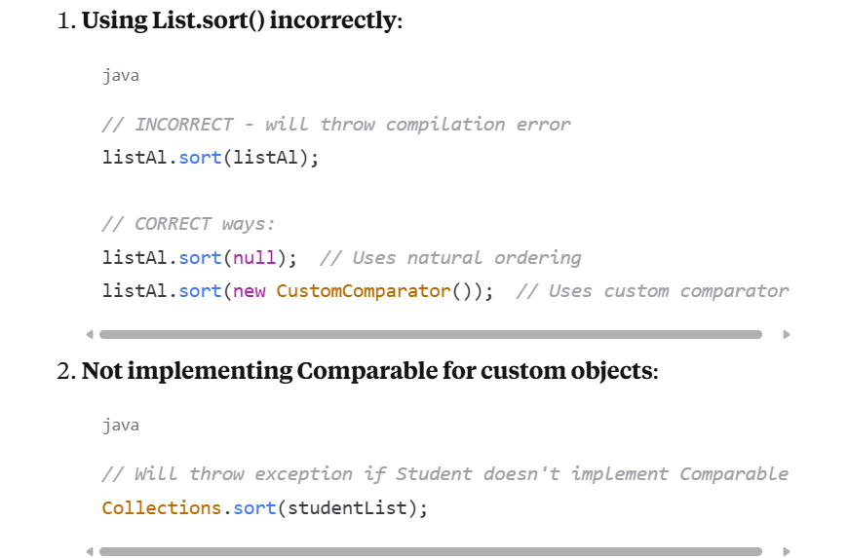

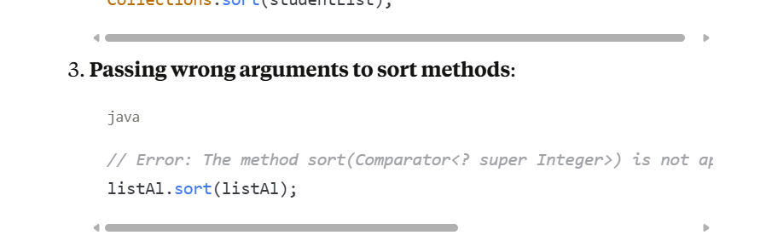

Custom CompareTo method

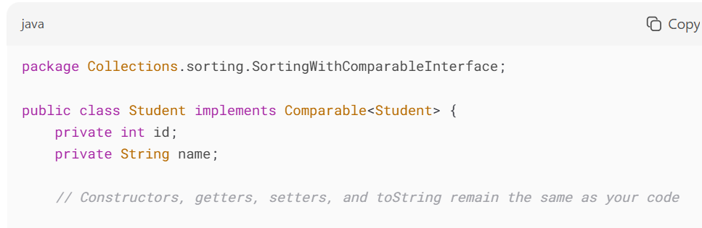

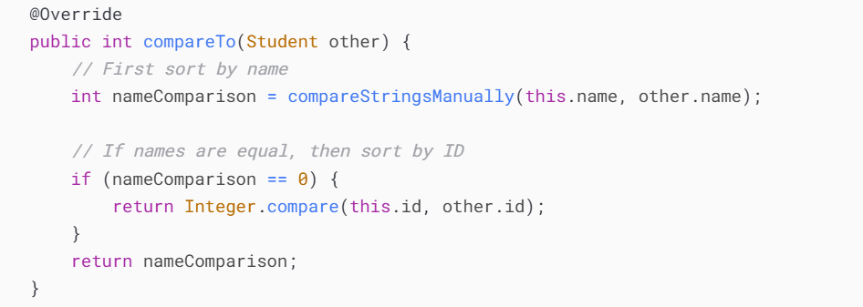

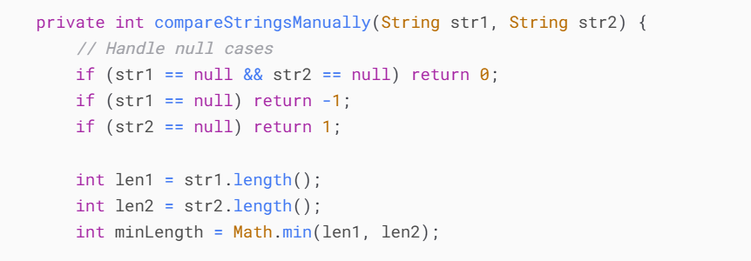

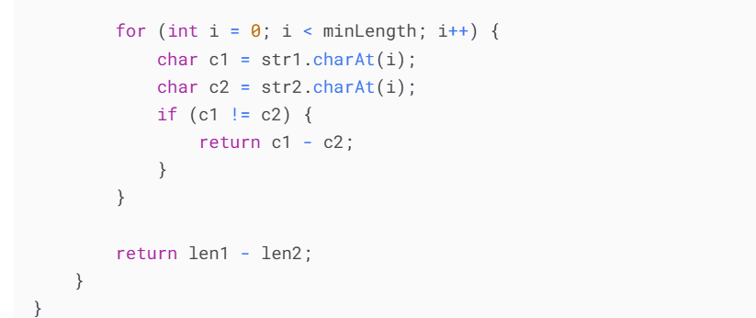

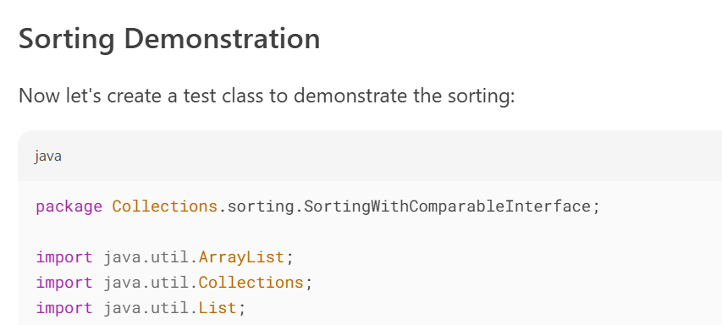

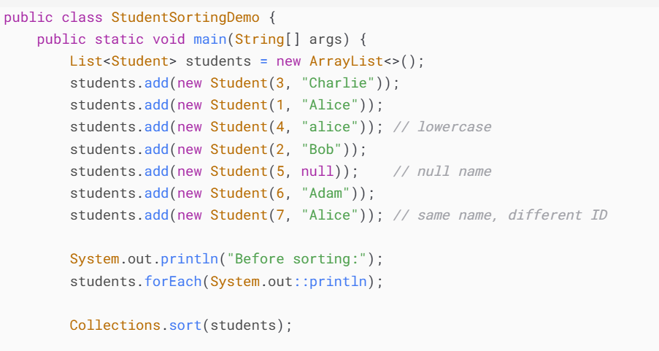

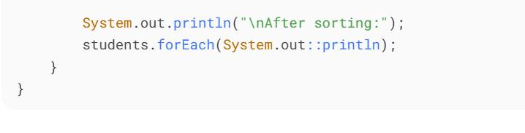

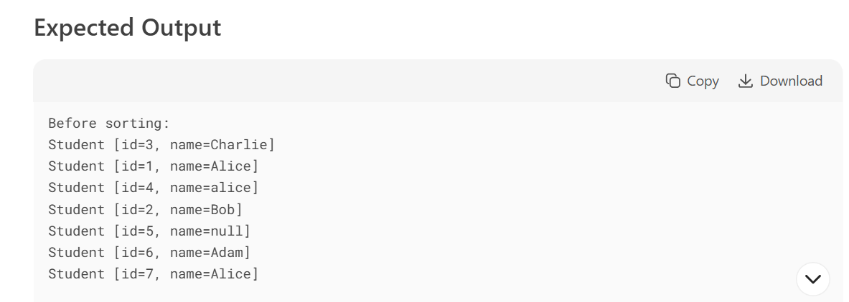

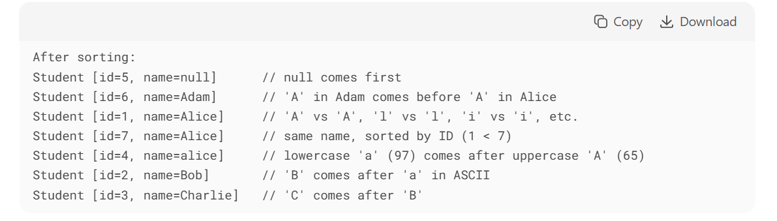

**Dry Run 1: compareStringsManually("Alice", "Bob")**

Step-by-Step Execution:

1. **Null Check**:
   * str1 = "Alice" (not null), str2 = "Bob" (not null)
   * All null conditions skipped
2. **Length Check**:
   * len1 = "Alice".length() → 5
   * len2 = "Bob".length() → 3
   * minLength = Math.min(5, 3) → 3
3. **Character Comparison Loop** (i = 0 to i = 2):
   * **First Iteration (i=0)**:
     + c1 = 'A' (ASCII 65)
     + c2 = 'B' (ASCII 66)
     + c1 != c2 → return 65 - 66 = -1
   * **Method returns**-1**immediately** (no further iterations)

**Final Return Value:** -1 (because "Alice" < "Bob")

**5.What is the Set Interface?**

The **Set interface** is part of the **Java Collection framework**. It represents a **collection of unique elements** where **no duplicate values** are allowed.

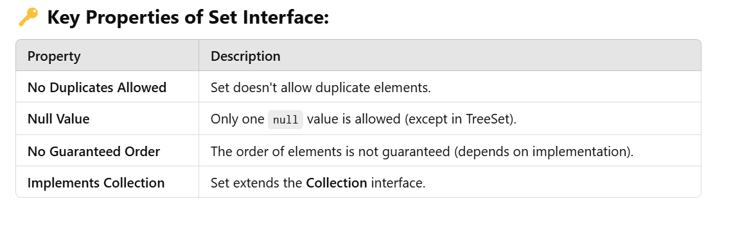

**Methods in the Set Interface:**

Since **Set** extends the **Collection** interface, it inherits all its methods. Here are the key methods of **Set**:

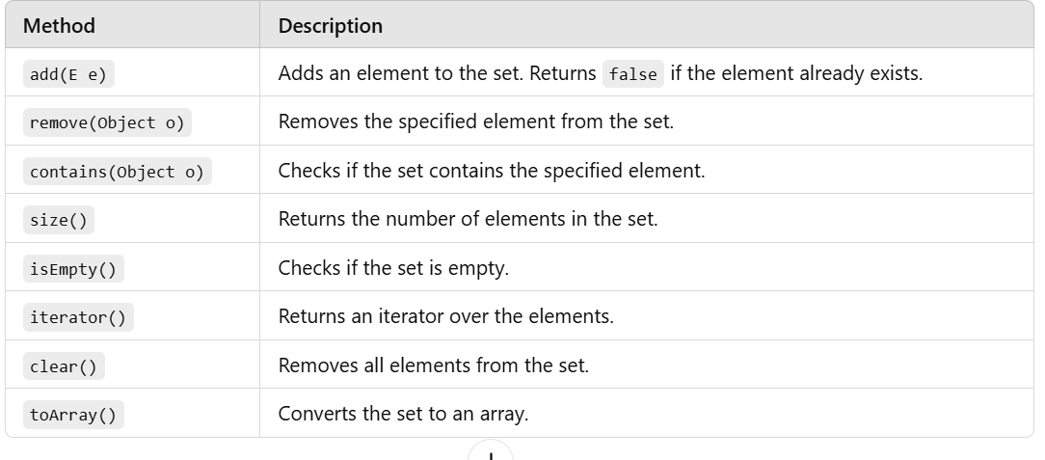

**Classes that Implement the Set Interface:**

1️⃣ **HashSet**

* **Uses HashMap internally** to store elements.
* **Does not maintain order** of elements.
* Allows **one null value**.
* **Fast** for operations like add, remove, and search.

2️⃣ **LinkedHashSet**

* Inherits from **HashSet**.
* **Maintains insertion order**.
* Allows **one null value**.

3️⃣ **TreeSet**

* Implements **NavigableSet** and **SortedSet**.
* Based on **Red-Black Tree**.
* **Maintains elements in sorted order**.
* **Does not allow null values**.

**📝 Common Use Cases of Set:**

* Removing duplicate values from a list.
* Storing unique elements like **IDs, usernames, or emails**.
* Performing **set operations** like union, intersection, and difference.

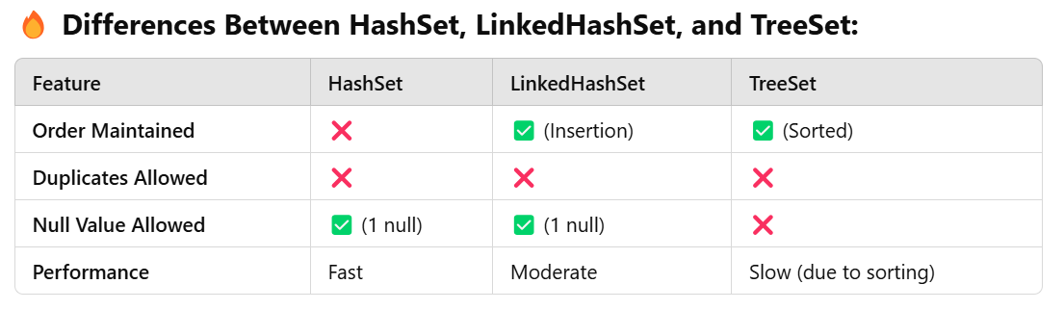

**Understanding the Data structure of Array, LinkedList and hashing**

**1. Array Data Structure**

**🔎 What is an Array?**

An **array** is a **linear data structure** that stores elements in **contiguous memory locations**. Each element in an array is accessed using an **index**.

**📂 How Array Stores Data:**

* The **size** of the array is fixed when it's created.
* All elements are stored **sequentially** in memory.
* Elements are accessed using an **index starting from 0**.

**📊 Example:**

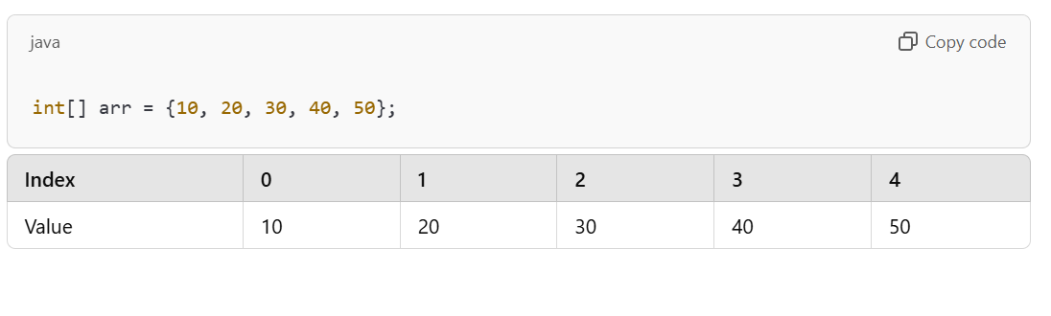

**Key Points:**

* **Access Time**: O(1) (because of indexing)
* **Insertion/Deletion Time**: O(n) (because elements need to shift)
* **Fixed Size**: Once created, the size of the array cannot be changed.

**🔧 Operations in Array:**

1. **Access**: Access any element using its index (e.g., arr[2] gives 30).
2. **Insert**: Inserting in the middle requires shifting elements.
3. **Delete**: Deleting requires shifting elements to fill the gap.

**2. LinkedList Data Structure**

**🔎 What is a LinkedList?**

A **LinkedList** is a **linear data structure** where **each element (node)** contains:

1. **Data**: The value of the node.
2. **Pointer**: A reference to the **next node** in the list.

**📂 How LinkedList Stores Data:**

* The elements are **not stored in contiguous memory locations**.
* Each node points to the **next node** in the list.
* The **last node points to null**, indicating the end of the list.

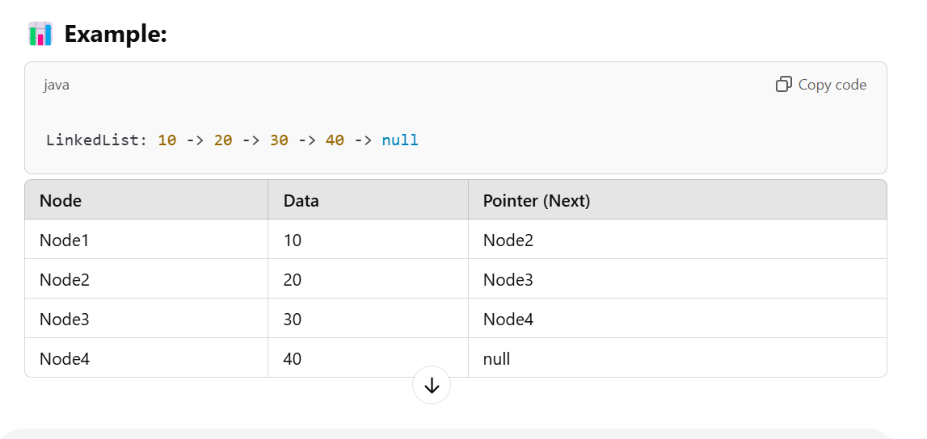

**Key Points:**

* **Dynamic Size**: The size of the LinkedList can grow or shrink as needed.
* **Insertion/Deletion**: Easier compared to arrays because no shifting is required.
* **Access Time**: O(n) (because you need to traverse the list to find an element).

**🔧 Operations in LinkedList:**

1. **Add**: Add a new node at the end or beginning.
2. **Remove**: Remove a node by updating the pointers.
3. **Traverse**: Go through each node to find or update data.

**Real-Life Example (Train Coaches)**

Imagine you are adding a new coach **(25)** between two existing coaches **(20)** and **(30)**:

1. **Unhook the chain** between **20** and **30**.
2. **Hook the new coach (25)** to **Coach 20**.
3. **Connect the chain from 25 to 30**

**Hashing Concept**

**What is Hashing?**

Think of **Hashing** as a way to **store and find data quickly** using a **key-value pair**.

Instead of searching through all the data (like in an array or LinkedList), **hashing** uses a **hash function** to calculate an **index** where the data should be stored.

**How HashMap Stores Data:**

1. A **HashMap** has an **array of buckets**.
2. Each **bucket** is like a slot in the array where values are stored.
3. The **hash function** takes the **key** and calculates the **index** of the bucket

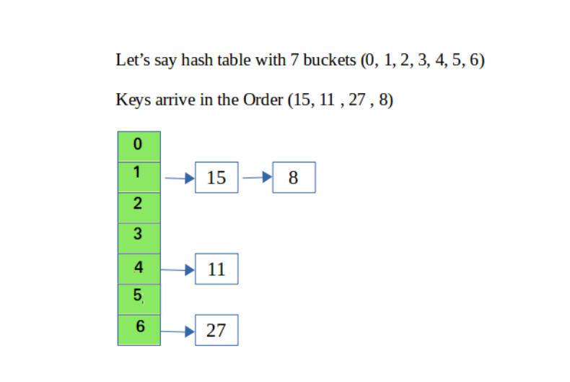

**What is a Hash Table?**

A **hash table** is a **data structure** that stores key-value pairs.  
The key is passed through a **hash function** to determine the **index** (bucket) in the array where the value should be stored.

**📚 Given Hash Table Example:**

* The hash table has **7 buckets** (index 0 to 6).
* Keys arrive in the order: **15, 11, 27, 8**.
* We use the **modulus operator (%)** as the hash function.

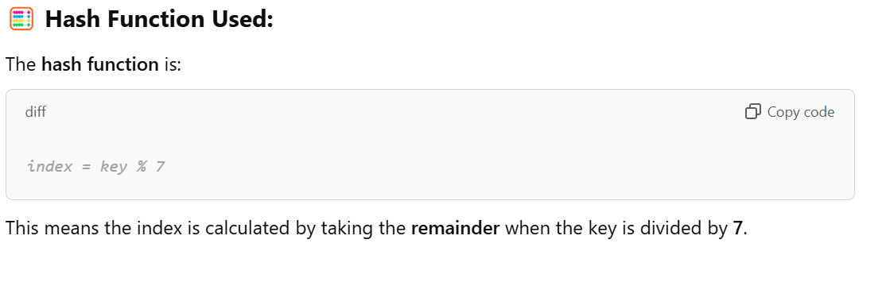

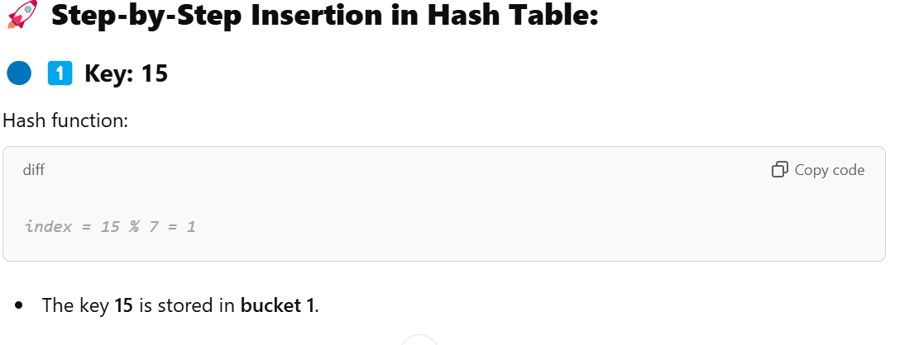

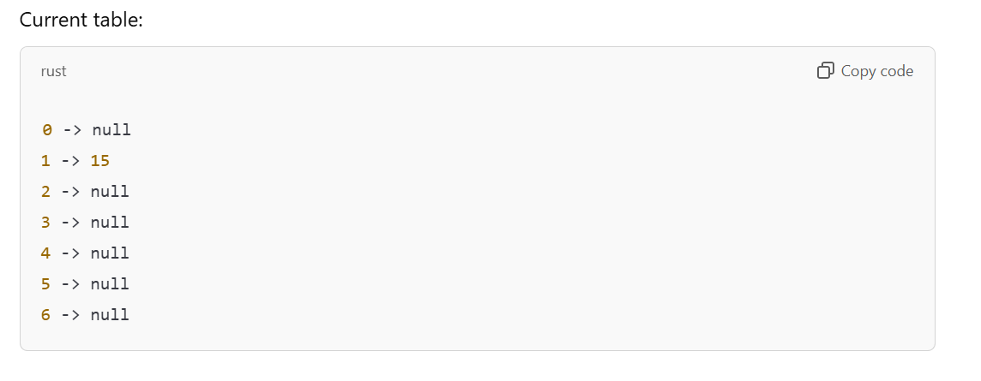

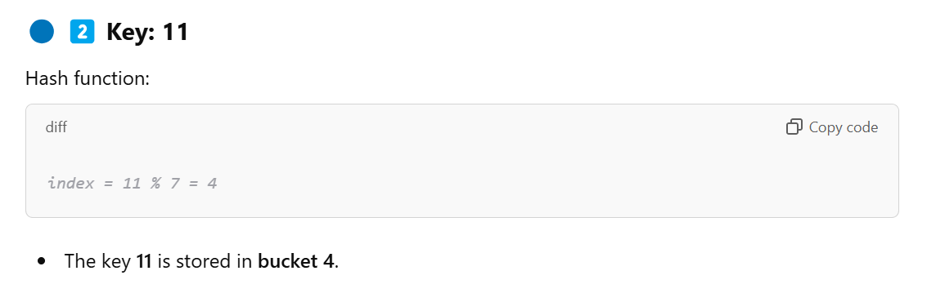

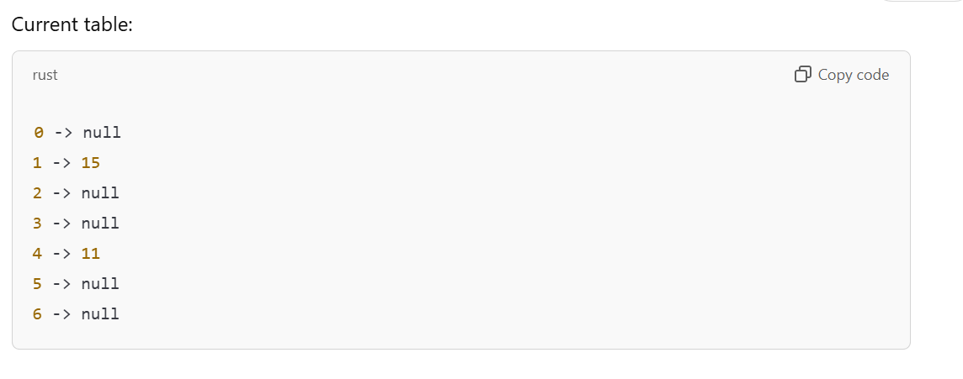

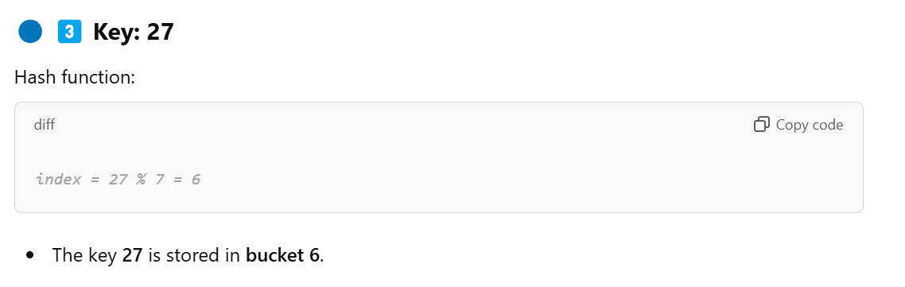

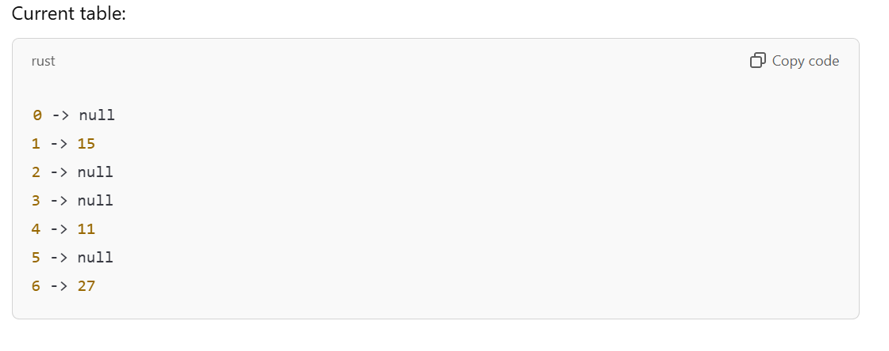

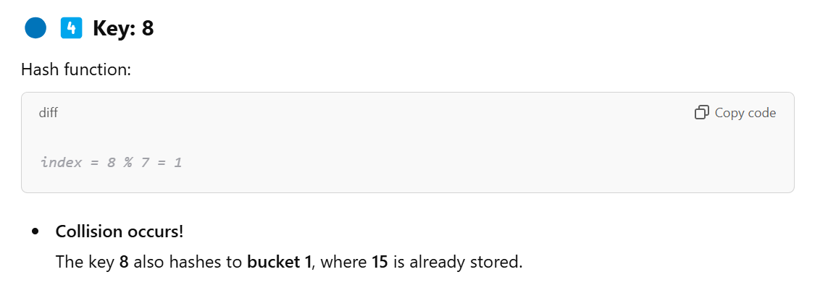

**Solution: Collision Handling Using Chaining**

In the hash table, collisions are handled using **chaining**. This means that each bucket holds a **linked list** to store multiple keys.

* **8** is added to the **linked list** at **bucket 1**, after **15**.

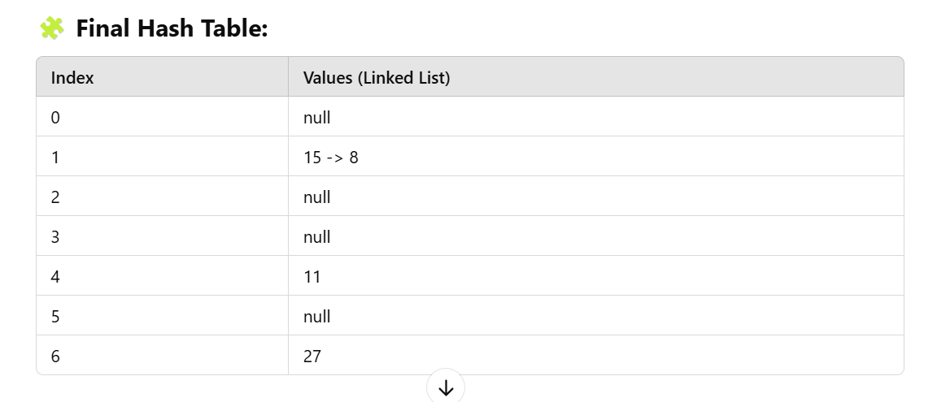

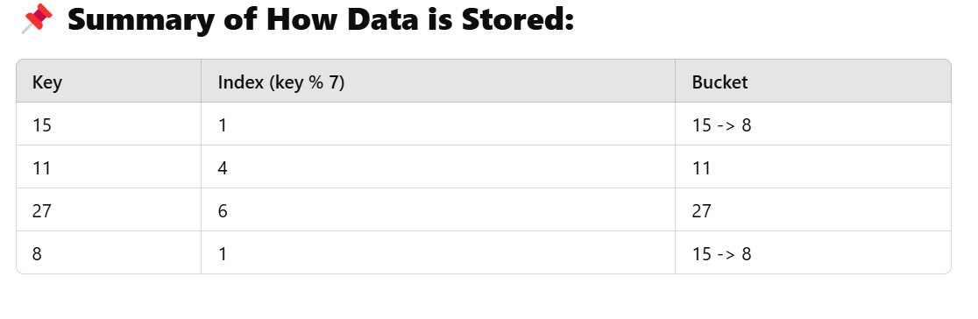

**How Hash Table Stores Keys and Values**

In a **HashMap (or hash table)**, we store data in **key-value pairs**. Here’s how the process works internally.

**✅ Step 1: Applying the Hash Function**

The **key** is passed to a **hash function**, which determines the **index (bucket)** where the key-value pair will be stored.

For example:

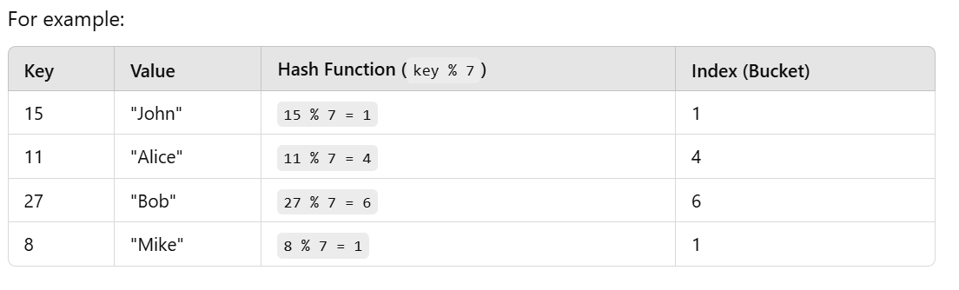

**tep 2: Storing Key-Value Pairs in the Hash Table**

Each **bucket (index)** in the hash table stores a **LinkedList of nodes**.  
Each **node** contains:

1. **Key** – The unique identifier (like 15, 11, 27).
2. **Value** – The data associated with that key (like "John", "Alice").
3. **Pointer** – Points to the next node in case of a collision (linked list chaining).

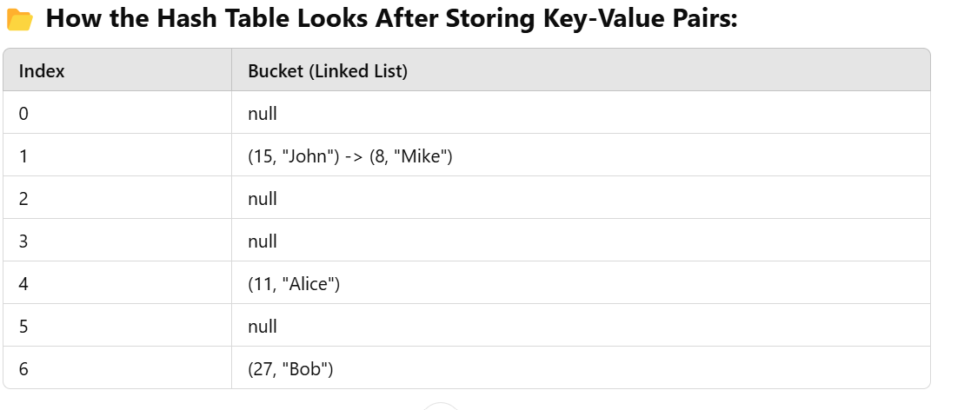

**Step 3: What Happens When a Collision Occurs?**

When two keys hash to the **same index**, a **collision** occurs.

In your example:

* **Key 15** hashes to **index 1**.
* **Key 8** also hashes to **index 1**.

To handle the collision, **HashMap uses chaining**:

* At **index 1**, the bucket now contains a **LinkedList**.
* The first node stores **(15, "John")**.
* The second node stores **(8, "Mike")**.

**Step 4: How HashMap Retrieves the Value**

When you try to **retrieve a value** using a key, the **HashMap** works like this:

1. **Apply the hash function** to the key to find the bucket (index).
2. **Traverse the LinkedList** in that bucket to find the key.
3. **Return the corresponding value**.

For example:

* If you search for **key 15**, the hash function gives **index 1**.
* At **index 1**, the LinkedList contains **(15, "John")** and **(8, "Mike")**.
* The HashMap compares the keys and finds **15**, then returns **"John"**.

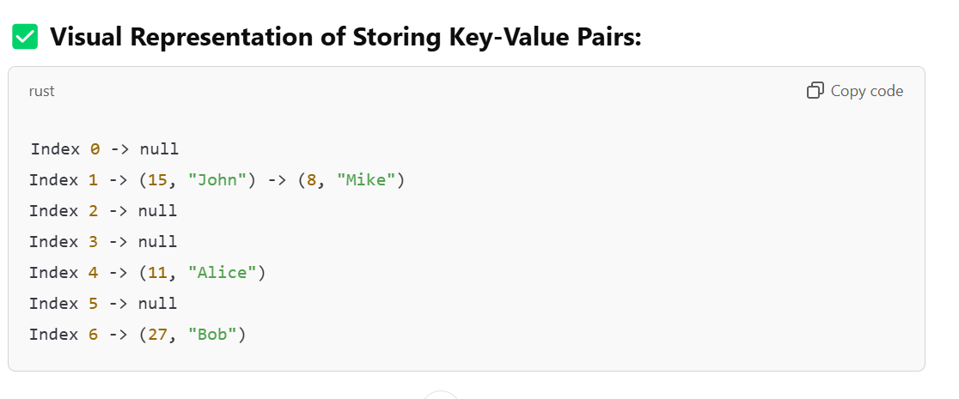

**Programmatic Example in Java:**

Here’s a **Java example** to demonstrate storing and retrieving key-value pairs in a HashMap.

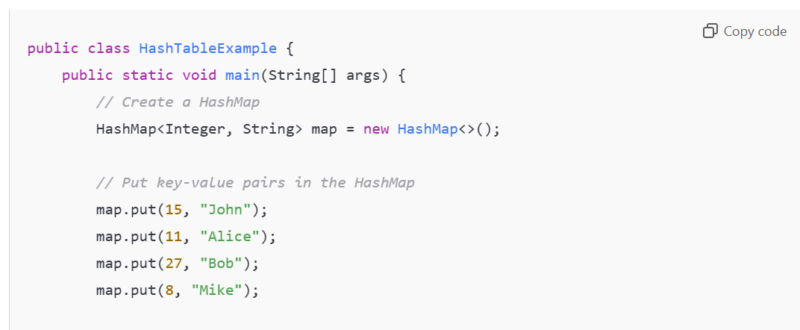

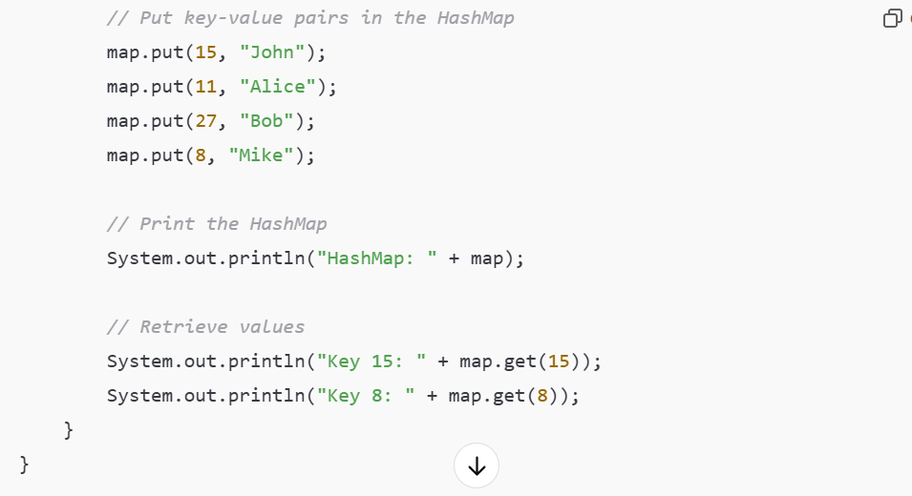

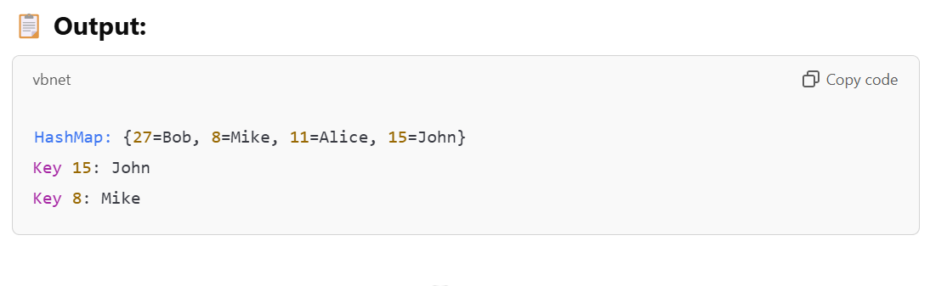 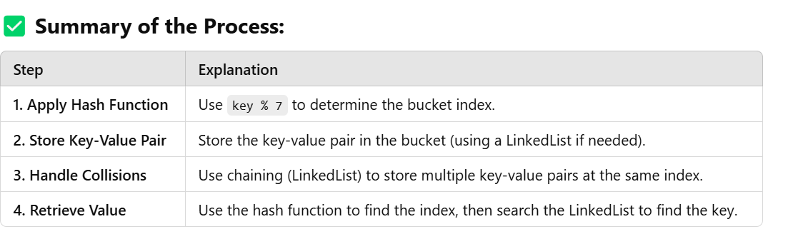

**Key Concepts to Remember:**

1. **Hash Function**:  
   A function that maps keys to a specific index in the hash table.  
   In this case: index = key % 7.
2. **Collision**:  
   When two keys are hashed to the same index.  
   Example: **15** and **8** both hashed to **bucket 1**.
3. **Collision Handling Using Chaining**:  
   A **linked list** is used at each bucket to handle multiple keys at the same index.

**What Happens if Two Keys Have the Same Index? (Collision)**

If two keys have the same index, it's called a **collision**.  
**HashMap** handles collisions using a **LinkedList** inside the bucket.

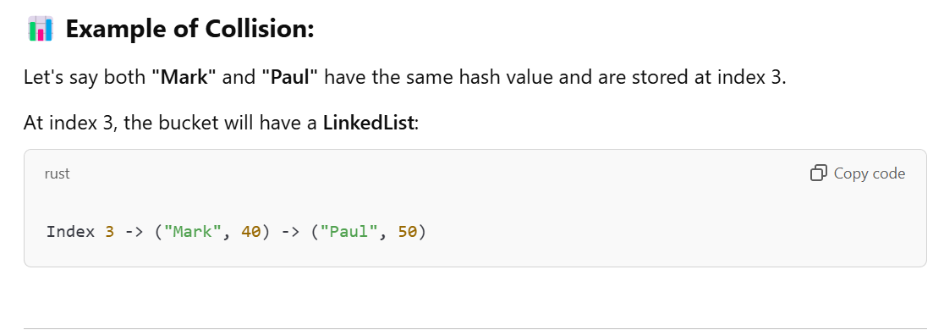

**Why Use Hashing?**

* **Fast Lookups**: Average time complexity is **O(1)**.
* **Efficient Storage**: Uses a combination of **array** and **LinkedList/tree**.

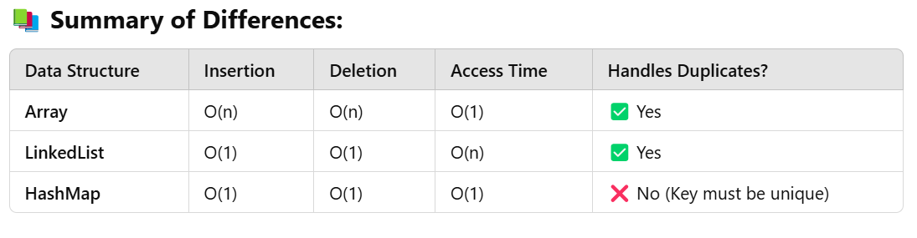

**What is a TreeSet in Java?**

A **TreeSet** is a part of **Java’s Collection framework** that implements the **Set interface** and is backed by a **TreeMap** (a type of self-balancing binary search tree).

**🔑 Key Properties of TreeSet:**

1. **No Duplicates Allowed** – Just like other Set implementations, **TreeSet** does not allow duplicate elements.
2. **Sorted Order** – **TreeSet stores elements in sorted (ascending) order**.
3. **No Null Elements Allowed** – TreeSet does not allow **null** values.
4. **Uses Red-Black Tree Internally** – TreeSet is implemented using a **self-balancing binary search tree** called a **Red-Black Tree**.

**⚙️ How TreeSet Works Internally?**

Internally, a **TreeSet** uses a **Red-Black Tree**, which is a **self-balancing binary search tree**. Here's how it works:

1. **Every element you add is stored in a node of the tree**.
2. The tree automatically maintains **sorted order** of elements.
3. The tree remains **balanced**, ensuring that all operations like **add**, **remove**, and **search** are efficient with a time complexity of **O(log n)**.

**🧩 How TreeSet Stores Data?**

Let’s say we add the following elements to a **TreeSet**:

makefile

Elements: 50, 30, 70, 20, 40, 60, 80

The TreeSet will organize these elements in **sorted order** using a **binary search tree** (BST):

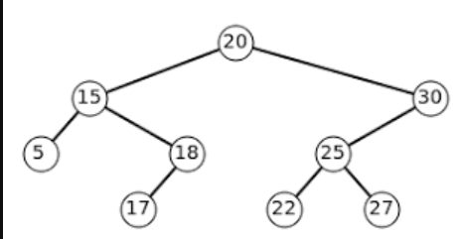

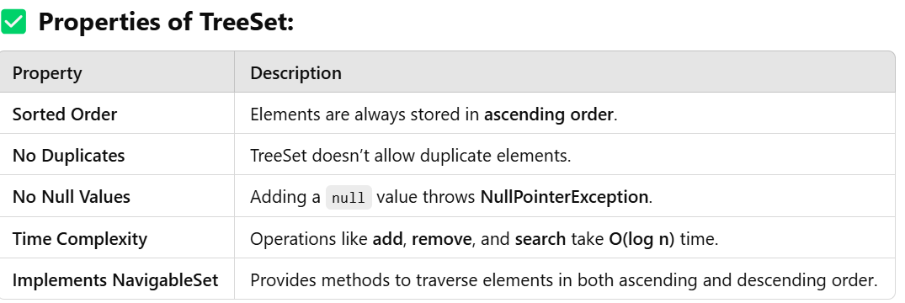

Java Example of TreeSet:

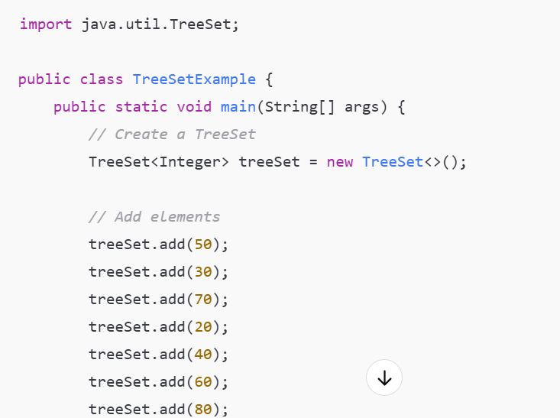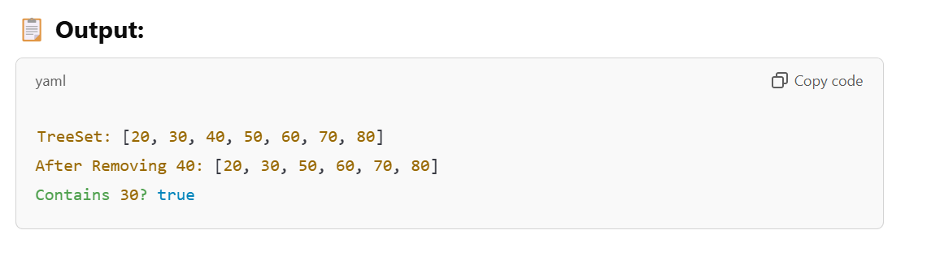

**What Happens When You Add Elements?**

Let's break down how elements are added to the TreeSet in **sorted order**.

**🔹 Adding 50:**

Since the tree is empty, **50** becomes the root node.

**🔹 Adding 30:**

**30** is smaller than **50**, so it goes to the **left** of **50**.

**🔹 Adding 70:**

**70** is greater than **50**, so it goes to the **right** of **50**.

**🔹 Adding 20:**

**20** is smaller than **50** and also smaller than **30**, so it goes to the **left of 30**.

The tree keeps adding elements in this manner while maintaining the **binary search tree property**.

**⚙️ How Does TreeSet Handle Duplicates?**

If you try to add a duplicate element, the TreeSet will simply **ignore** it.

**Example:**

java

Copy code

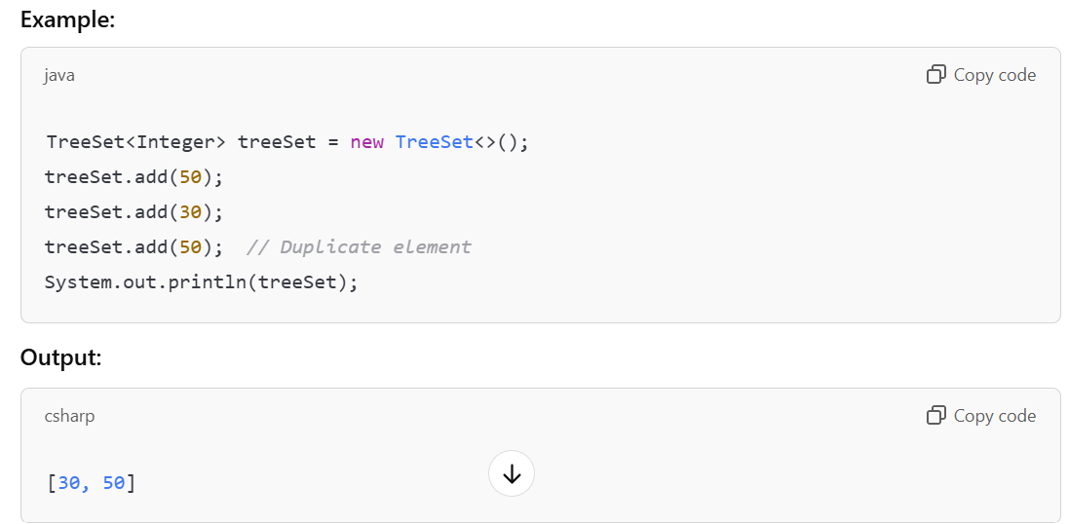

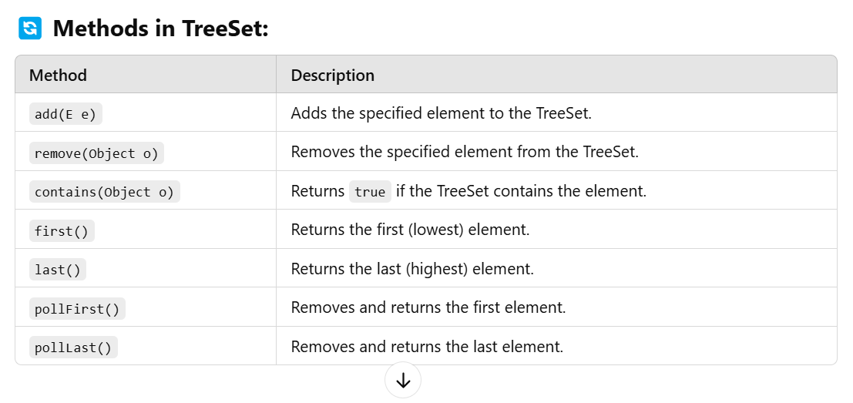

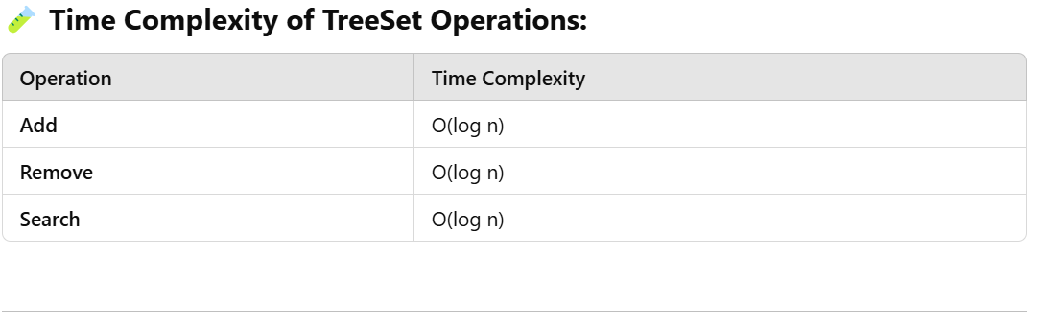

**Advantages of TreeSet:**

1. **Automatically sorts elements**.
2. Efficient for **range-based operations** (like finding elements within a specific range).
3. Provides methods to traverse in **both ascending and descending order**.

**🚫 Disadvantages of TreeSet:**

1. **Slower than HashSet** because of sorting.
2. **Does not allow null values**.
3. **More memory usage** compared to HashSet.

**Summary:**

1. **TreeSet** is a part of the **Set interface**.
2. It stores elements in **sorted order** using a **Red-Black Tree**.
3. It does **not allow null values** and ignores **duplicate elements**.
4. Operations like **add**, **remove**, and **search** take **O(log n)** time.
5. **Best for range-based queries** and when sorting is required.

**HashSet in Java**

**HashSet** is a class that implements the **Set interface** and is backed by a **HashMap**. It **does not allow duplicate elements** and **does not maintain any order**.

**✅ Key Properties of HashSet:**

**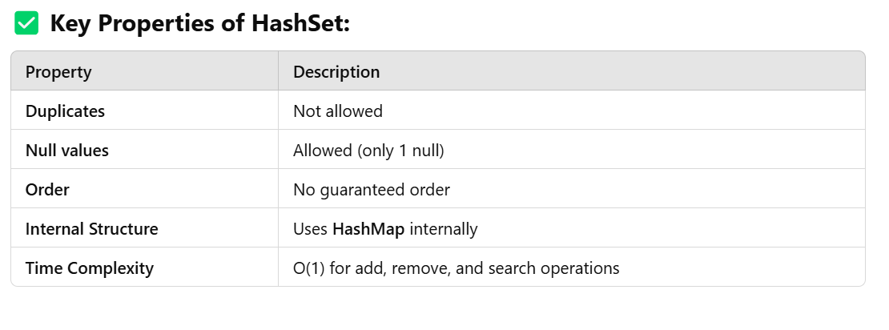**

**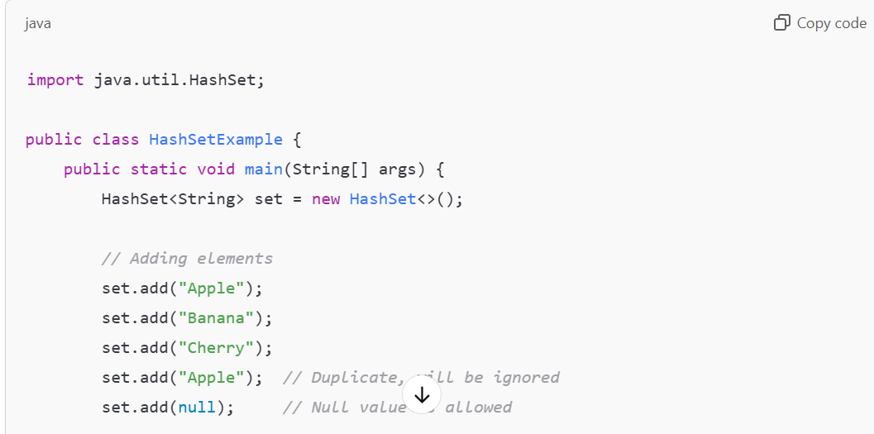**

**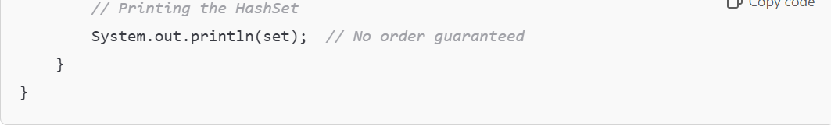**

**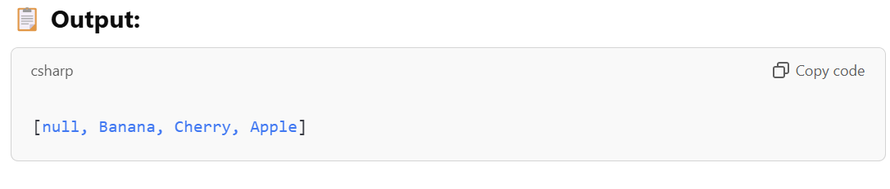**

**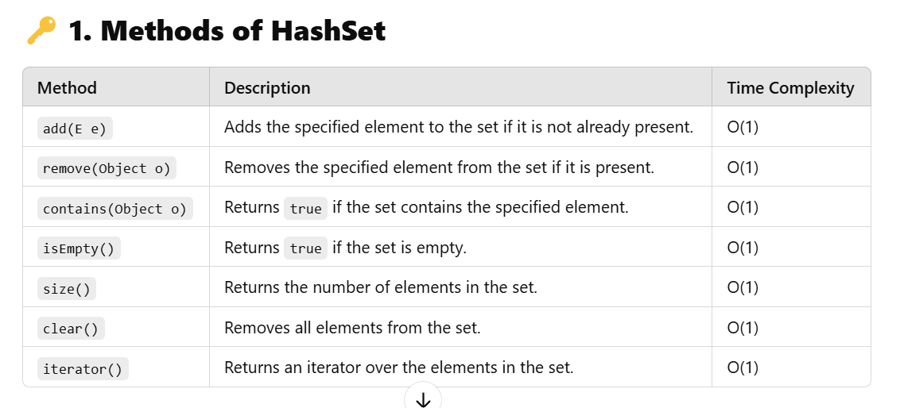**

**When to Use HashSet?**

* **When you need to store unique elements and don’t care about order.**
* **For fast access operations.**

**LinkedHashSet in Java**

**LinkedHashSet** is a subclass of **HashSet** that **maintains the insertion order**. It uses a **combination of HashMap and LinkedList** internally.

**✅ Key Properties of LinkedHashSet:**

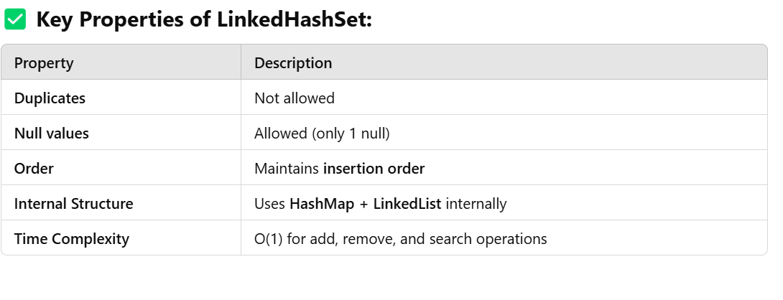

**Example of LinkedHashSet:**

**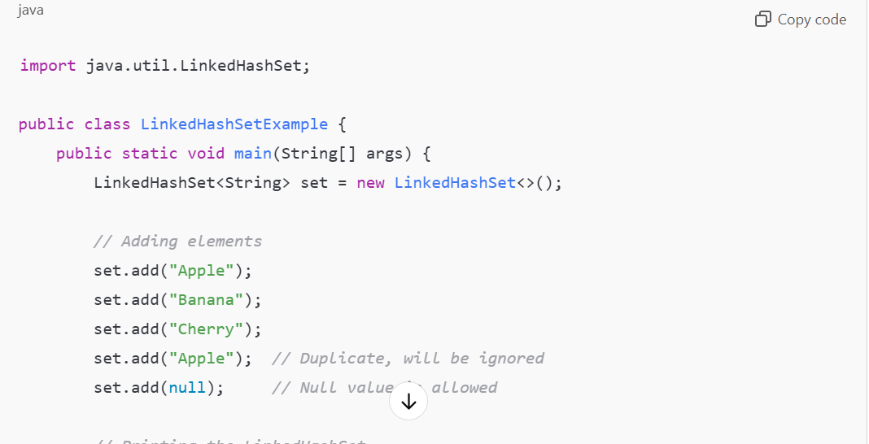**

**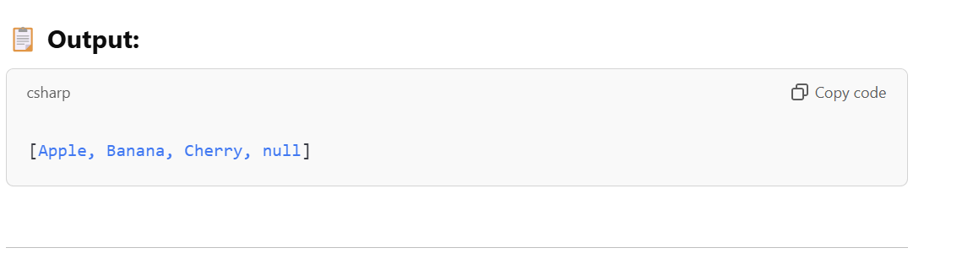**

1. **Methods of LinkedHashSet**

**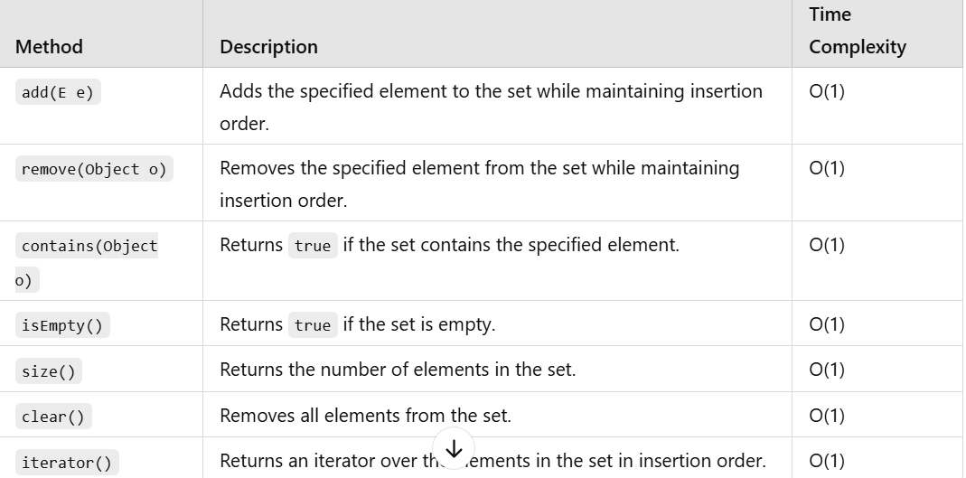**

**When to Use LinkedHashSet?**

* When you need to store **unique elements** and **maintain the insertion order**.

**🔎 TreeSet in Java**

**TreeSet is a class that implements the NavigableSet interface and is backed by a Red-Black Tree. It stores elements in sorted order.**

**✅ Key Properties of TreeSet:**

**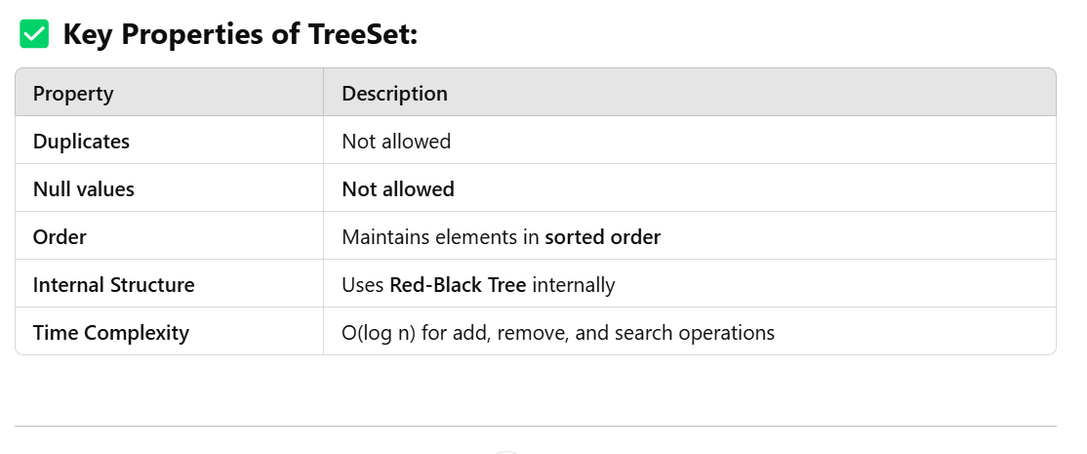**

**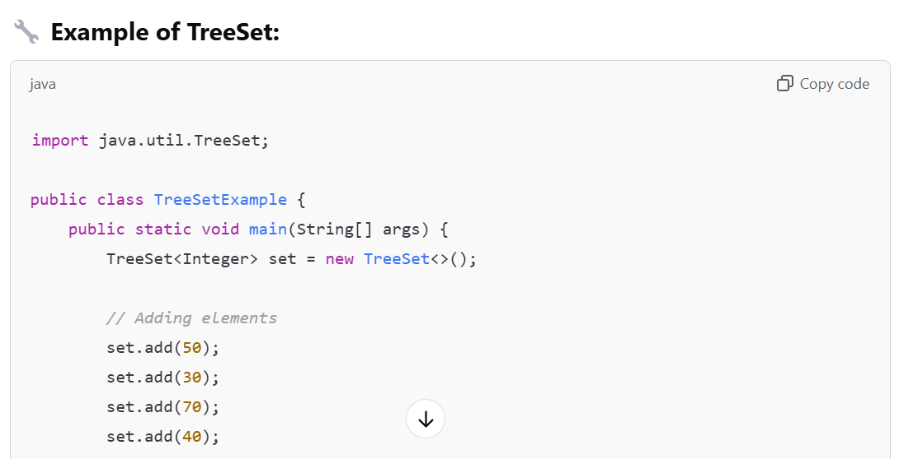**

**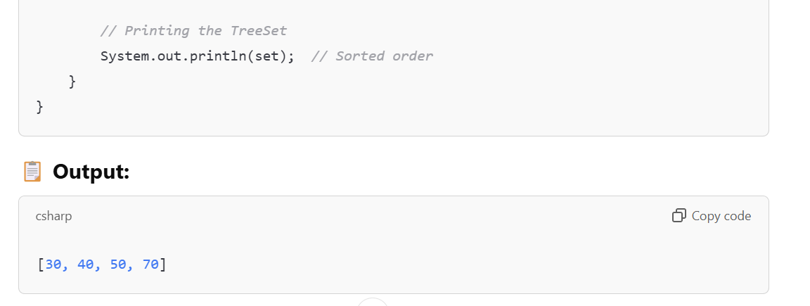**

**Methods of TreeSet**

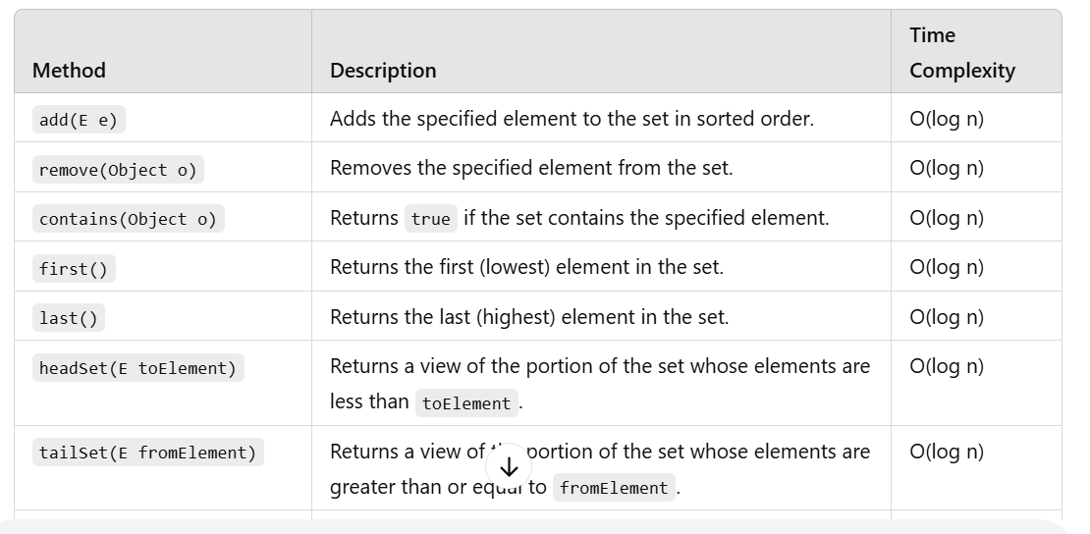

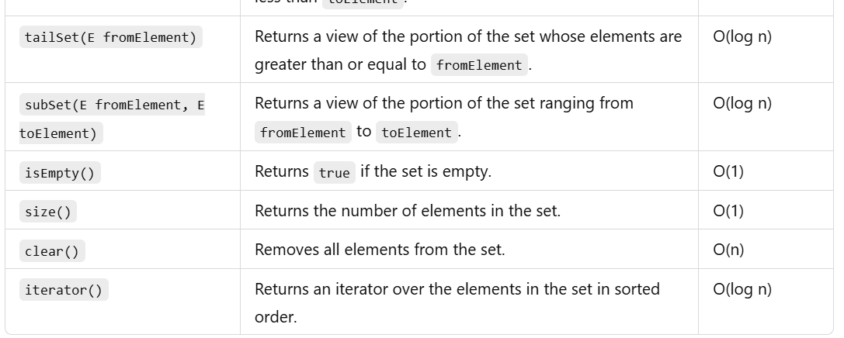

**When to Use TreeSet?**

* **When you need to store unique elements in sorted order.**

**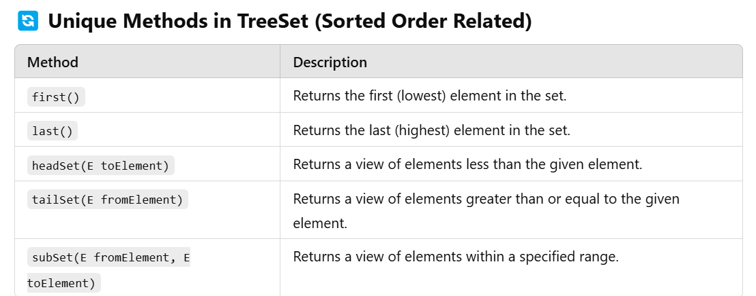**

**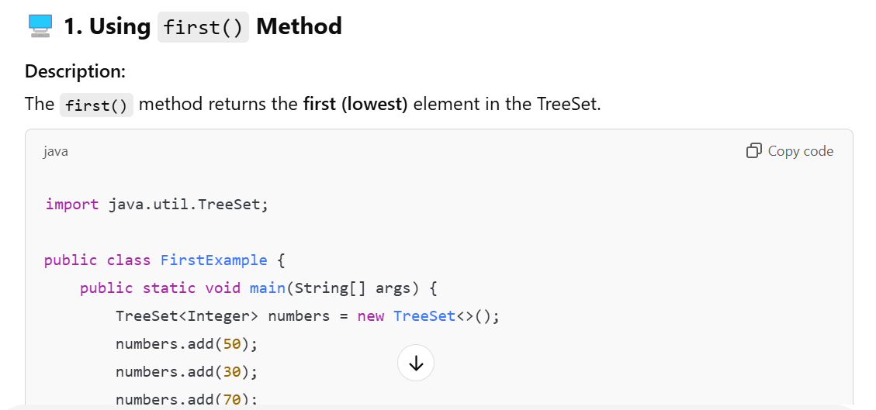**

**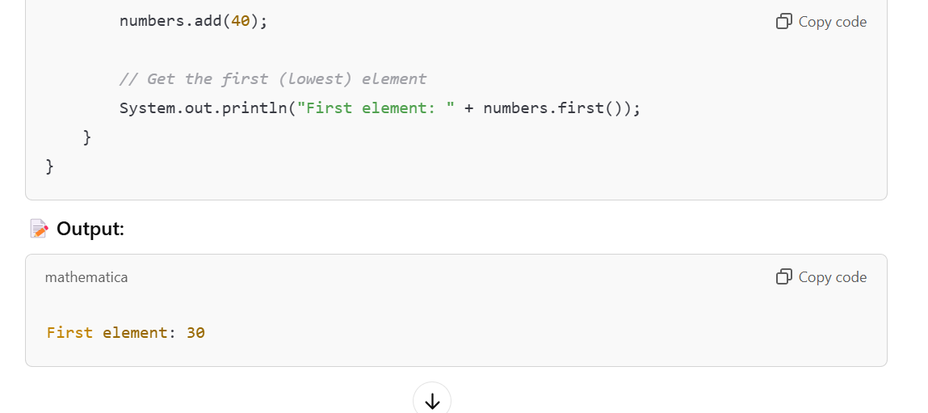**

**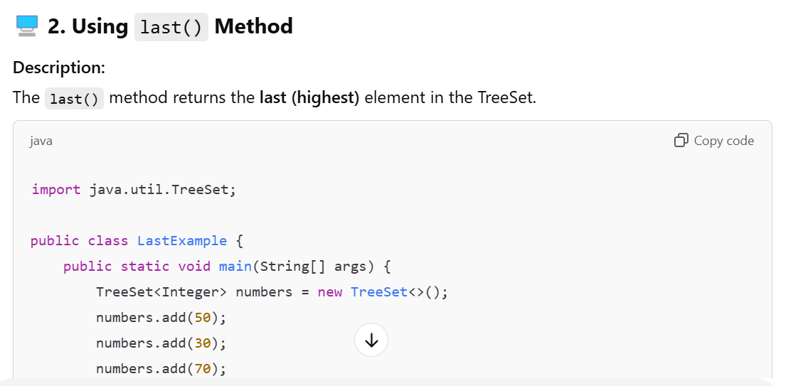**

**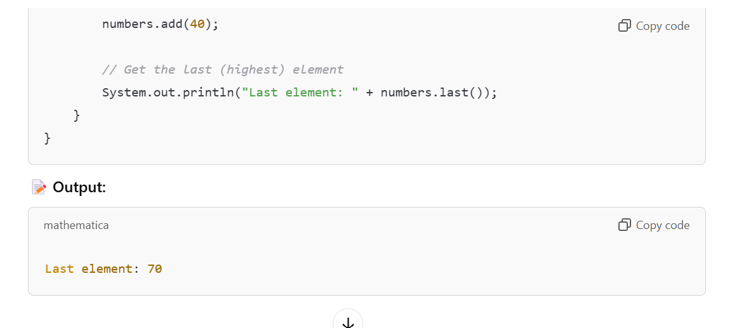**

**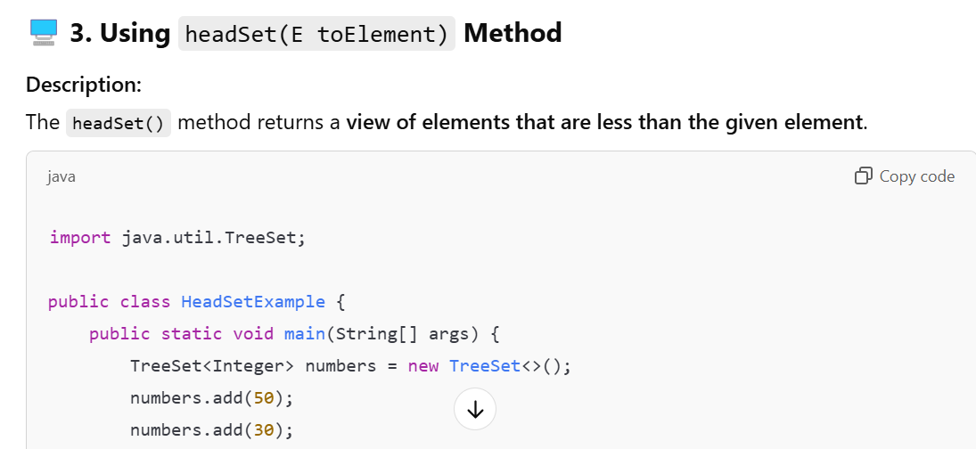**

**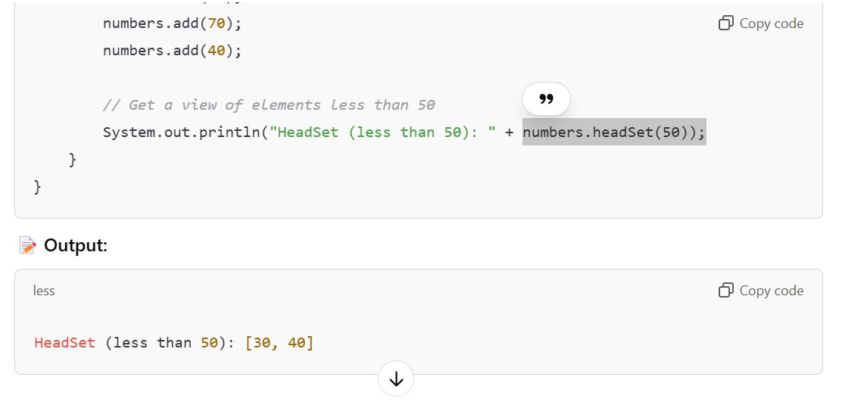**

**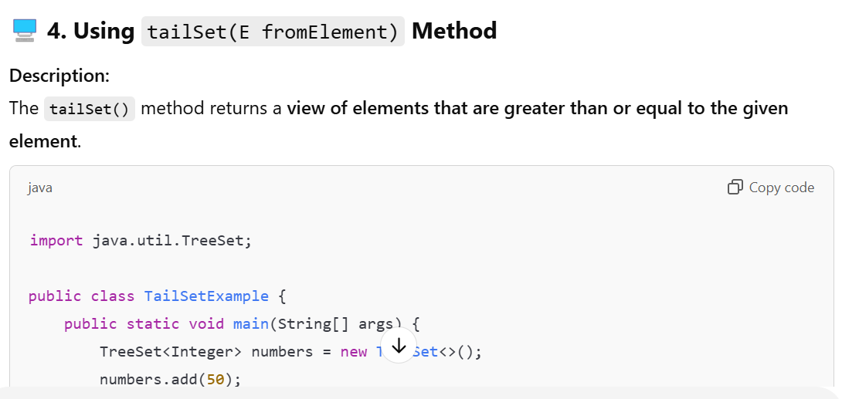**

**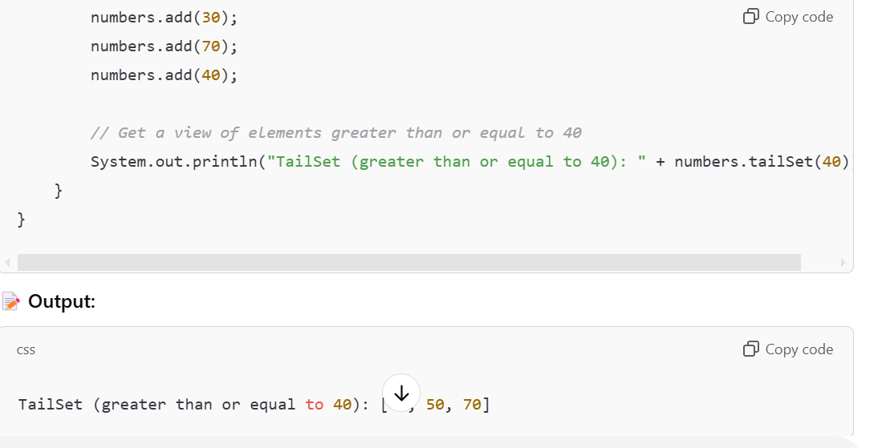**

**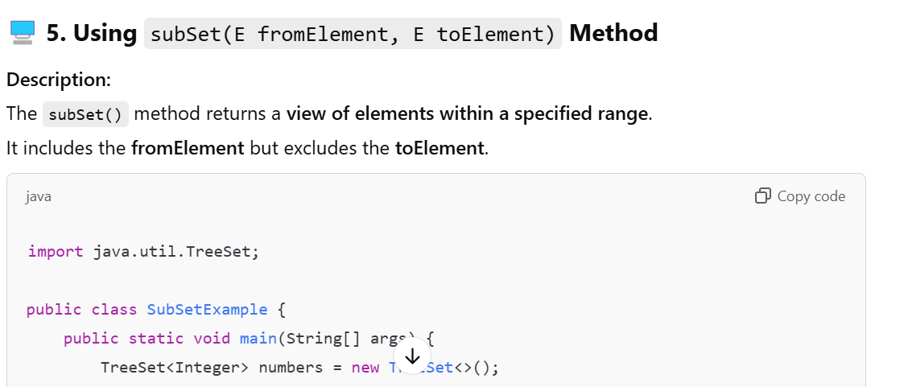**

**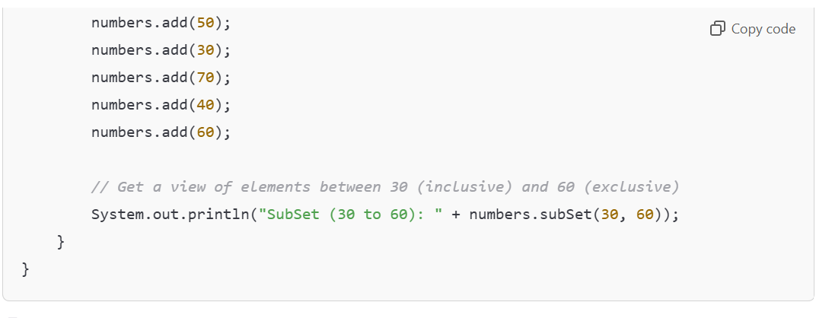**

**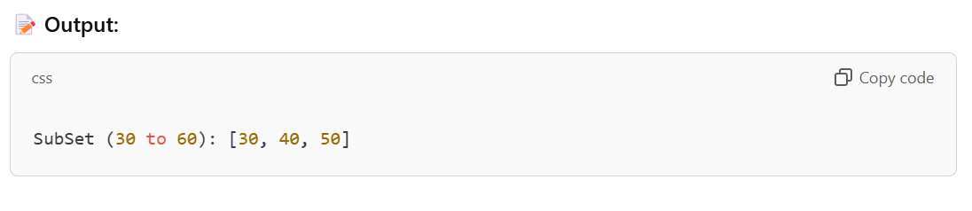**

**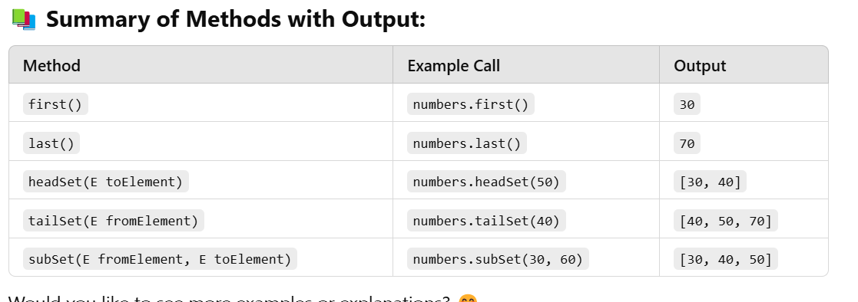**

**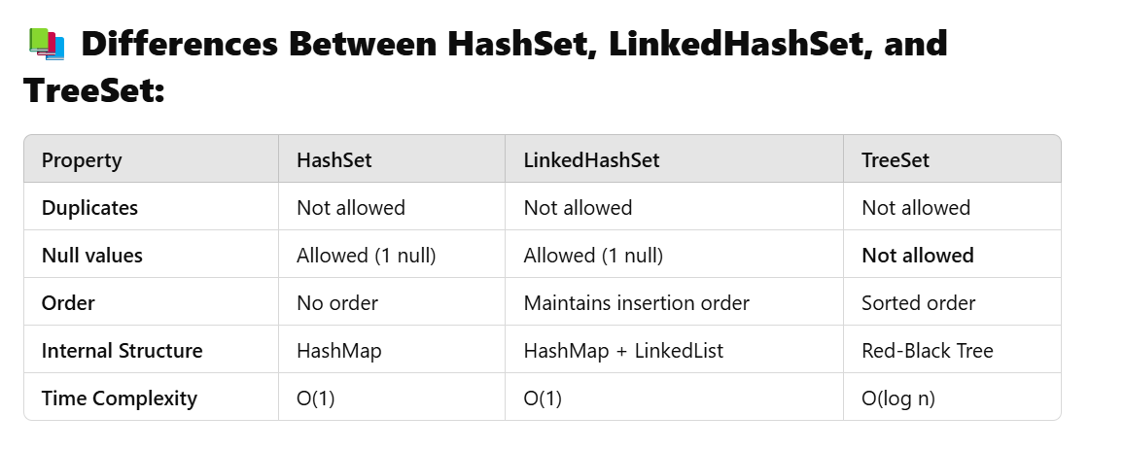**

**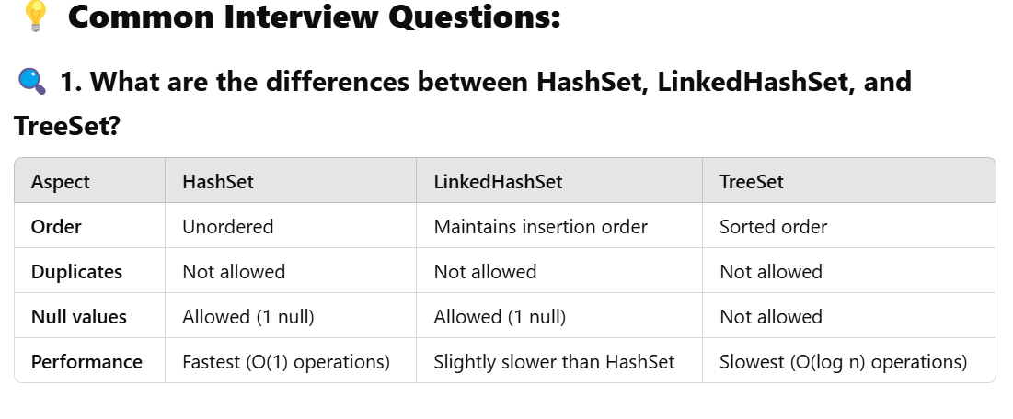**

**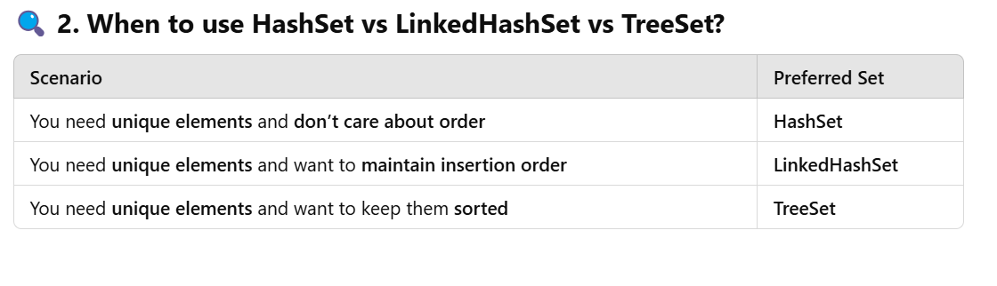**

**3. Why doesn’t TreeSet allow null values?**

* TreeSet uses a **Red-Black Tree** internally, and it needs to compare elements to maintain **sorted order**.
* If you try to add a **null** value, the comparison will throw a **NullPointerException** because **null cannot be compared** to other elements.

**4. How does HashSet handle duplicates?**

* **HashSet** uses a **HashMap** internally.
* When you try to add a duplicate element, the **HashMap checks if the key already exists**.
* If the key exists, the new value is **ignored**.

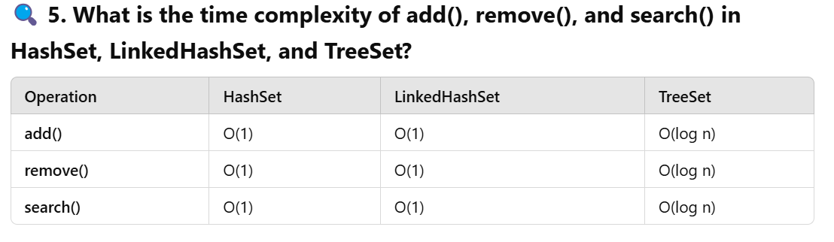

**1. What is a Queue in Java?**

**🔎 Definition**

A **Queue** is a **linear data structure** that follows the **FIFO (First-In-First-Out)** principle. The first element added to the queue is the first one to be removed.

**⚙️ Key Characteristics of Queue:**

* **FIFO (First-In-First-Out)**
* Elements are added at the **rear** and removed from the **front**.
* **Null values are not allowed** in most queue implementations.

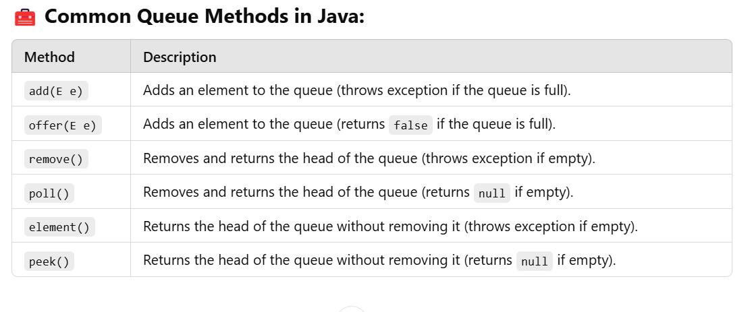

**Example of Queue Using LinkedList:**

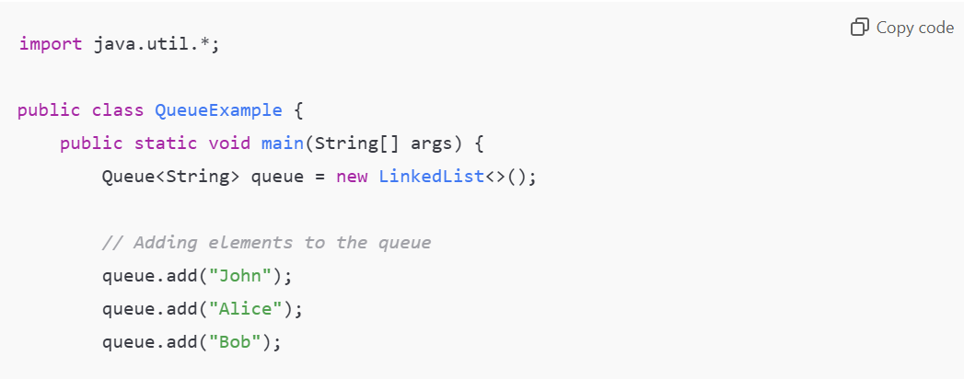

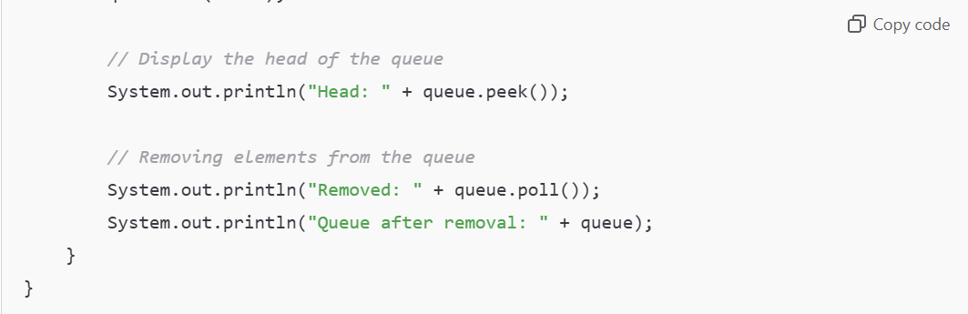

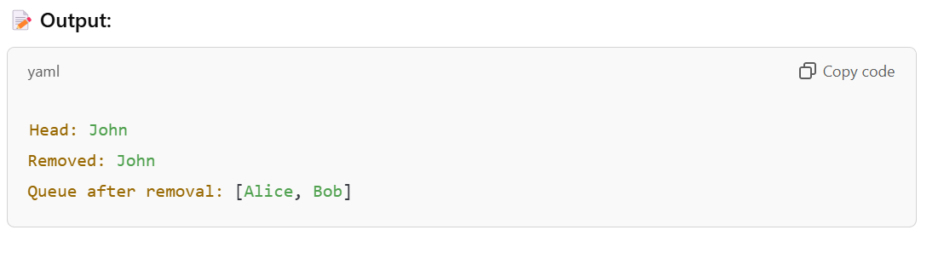

**2. What is a PriorityQueue in Java?**

**Definition**

A **PriorityQueue** is a special type of queue in which **elements are ordered based on their natural ordering (ascending order)** or by a **custom comparator**.

**⚙️ Key Characteristics of PriorityQueue:**

* Elements are ordered based on **priority**.
* It does **not follow FIFO**.
* **Null values are not allowed**.
* **Duplicates are allowed**.

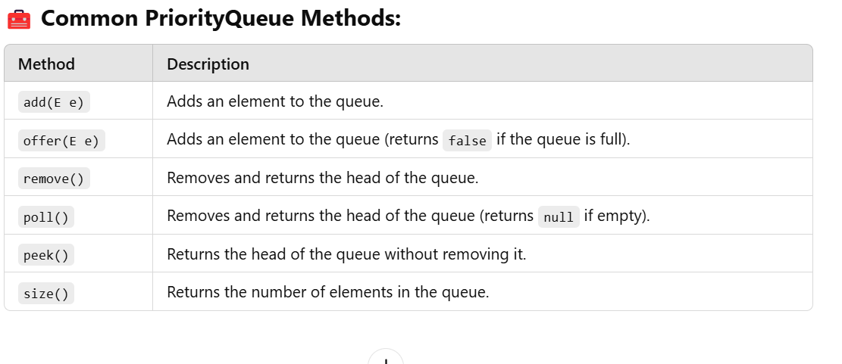

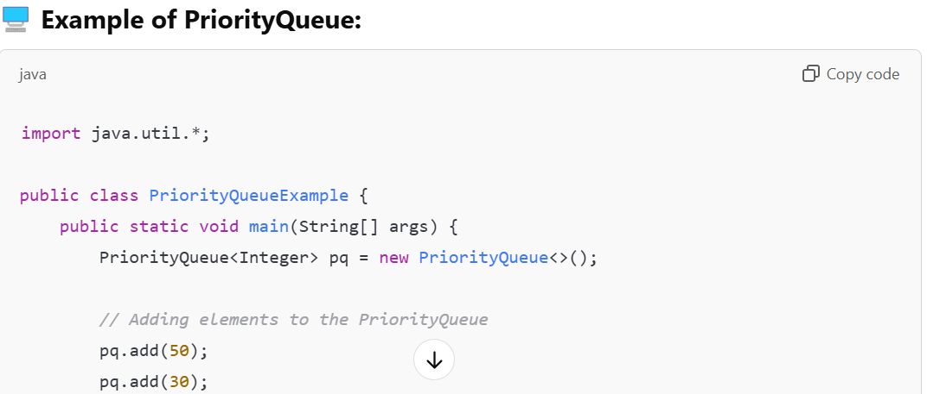

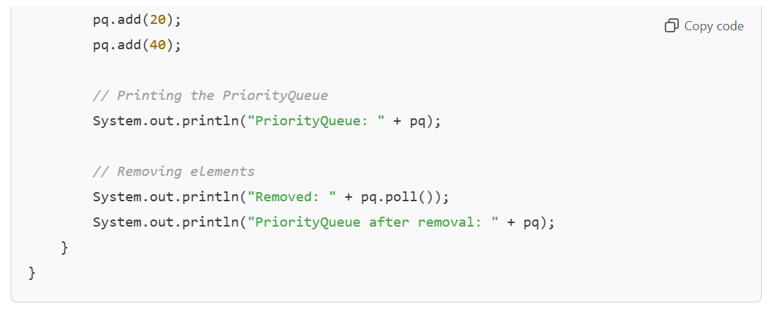

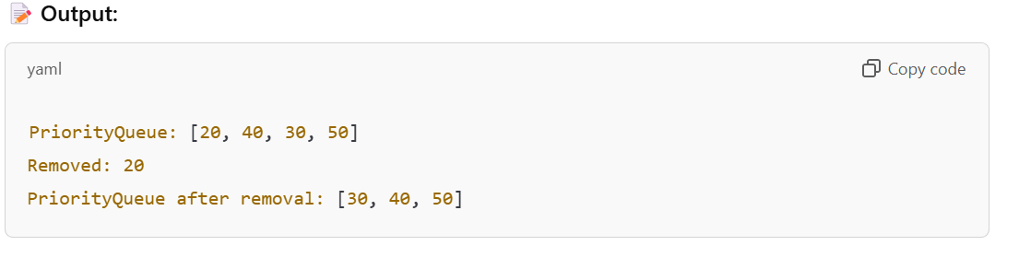

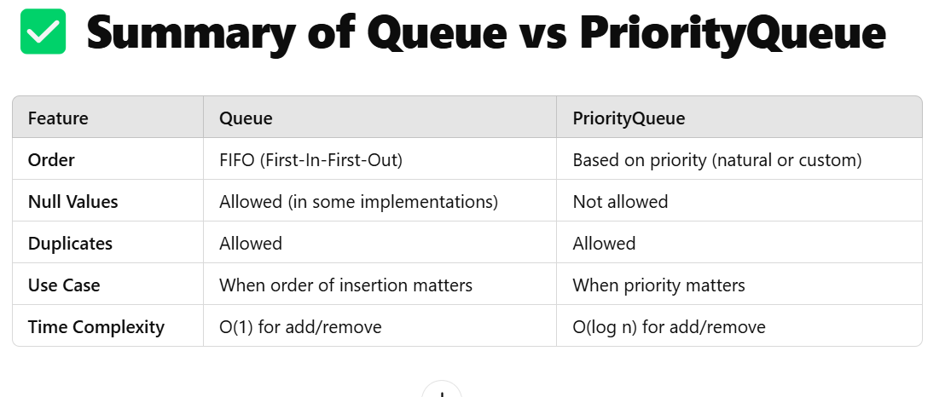

**4.Custom PriorityQueue in Java**

**Definition**

A **Custom PriorityQueue** allows you to define your **own priority rules** using a **Comparator**.

**🧰 How to Create a Custom PriorityQueue?**

1. Use the **PriorityQueue** class and pass a **Comparator** to its constructor.
2. The **Comparator** defines the custom sorting logic.

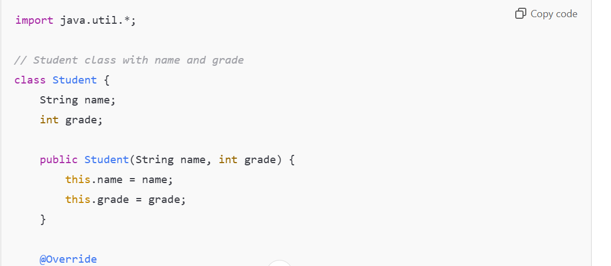

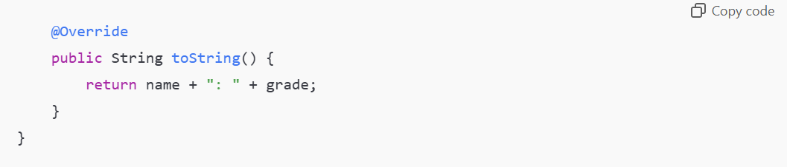

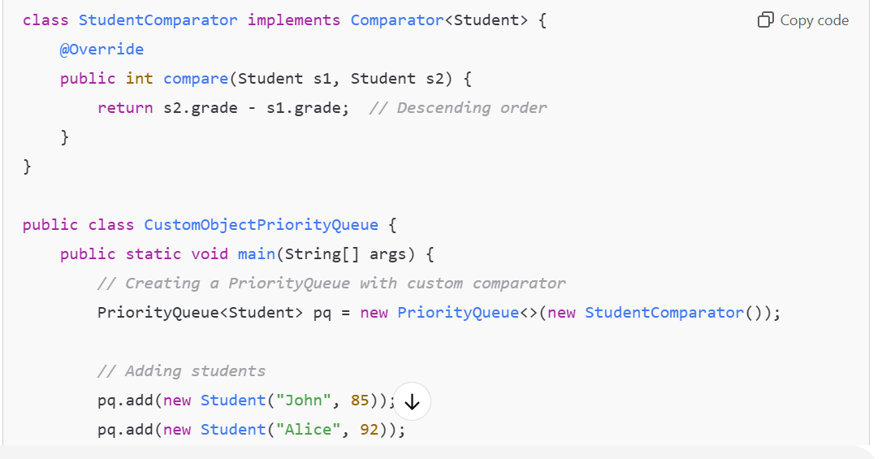

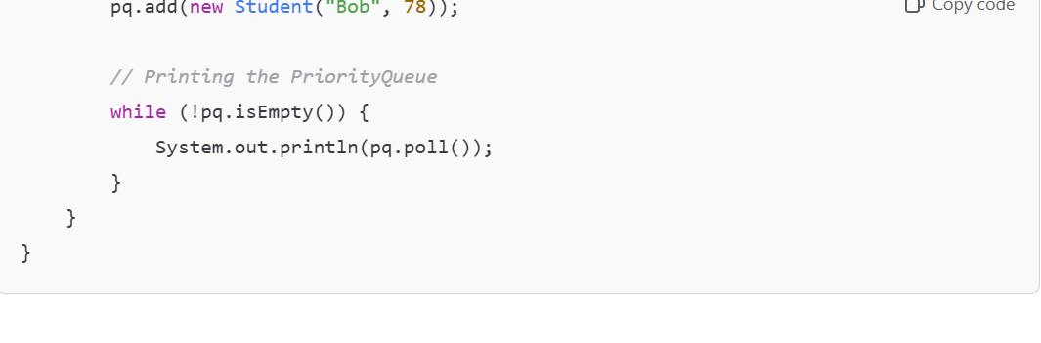

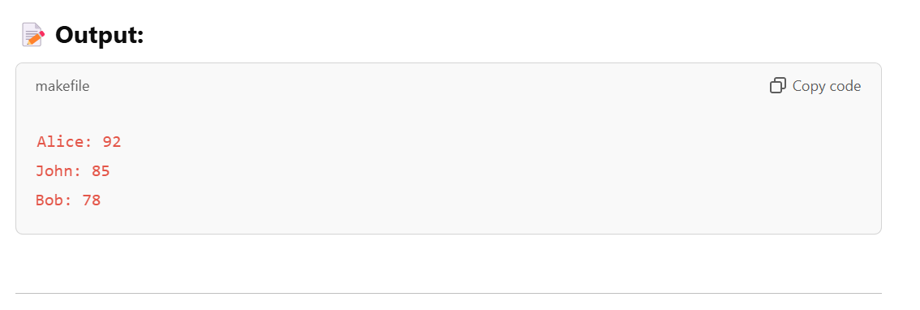

**How the Code Works:**

1. **Student Class:**
   * Contains **name** and **grade** fields.
   * Overrides the **toString()** method for clean output.
2. **StudentComparator Class:**
   * Implements **Comparator<Student>**.
   * Compares **grades** in **descending order**.
3. **Main Class (CustomObjectPriorityQueue):**
   * Creates a **PriorityQueue** with the custom comparator.
   * Adds **Student objects** to the queue.
   * Uses **poll()** to retrieve and print elements in **priority order**.

**✅ Introduction to Map in Java**

The **Map interface** in Java is a part of the **Java Collections Framework**, but it is **not a subtype of the Collection interface**. Unlike other collections like **List** or **Set**, which store individual elements, **Map stores data in key-value pairs**.

**🧩 Key Features of Map:**

* **Map stores key-value pairs** where each key is unique.
* **Keys cannot be duplicate**, but **values can be duplicated**.
* A **key maps to a single value**, and each key-value pair is known as an **entry**.
* **Null keys** and **null values** are allowed, but behavior depends on the specific Map implementation.

**⚙️ Why Map is Not a Collection?**

Although **Map** is part of the **Collections Framework**, it is **not a subtype of the Collection interface** because:

1. **Collection works with individual elements**, while **Map works with key-value pairs**.
2. **Collection methods like add(), remove(), etc., don’t make sense for a Map**.

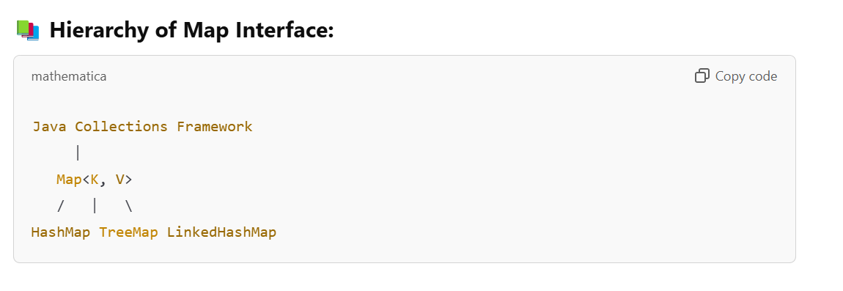

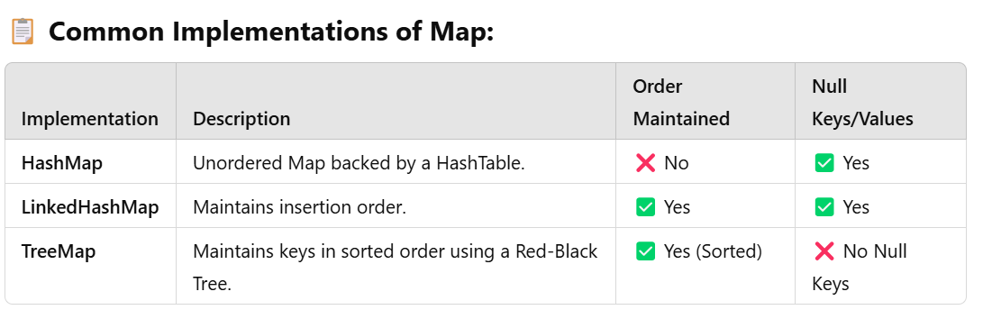

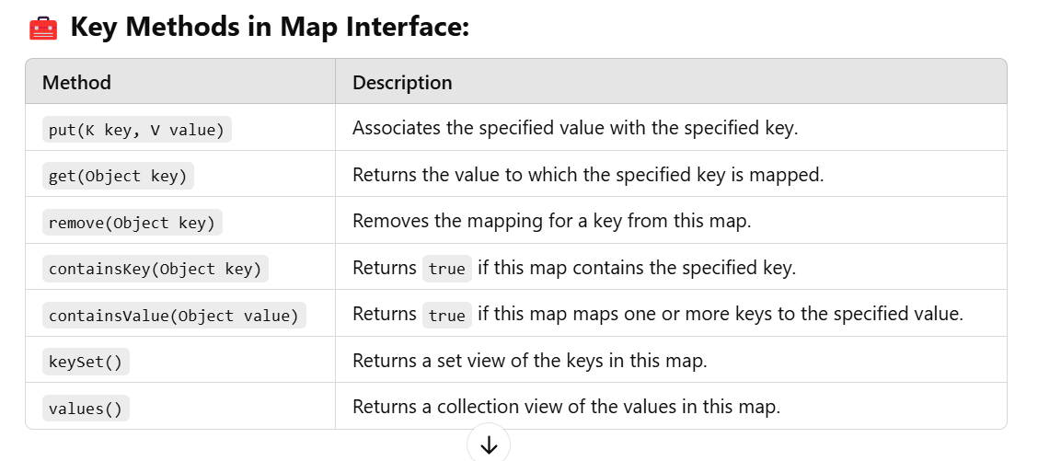

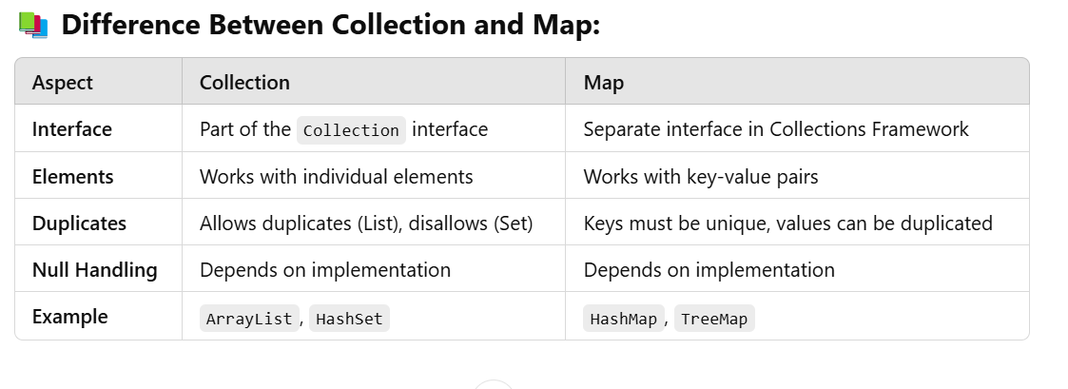

Here’s a complete explanation of **HashMap**, **TreeMap**, **LinkedHashMap**, and **Hashtable** in Java with their **methods**, **examples**, and **common interview questions** to help you prepare for interviews.

**📚 1. HashMap in Java**

**🔎 What is HashMap?**

**HashMap** is a class that implements the **Map interface** and stores **key-value pairs**. It uses a **HashTable** internally to store data and provides **constant-time performance (O(1))** for basic operations like **add**, **remove**, and **get**.

**⚙️ Key Features of HashMap:**

* **No order is maintained**.
* **Allows one null key** and **multiple null values**.
* **Fast performance** for large datasets.
* **Not thread-safe**.

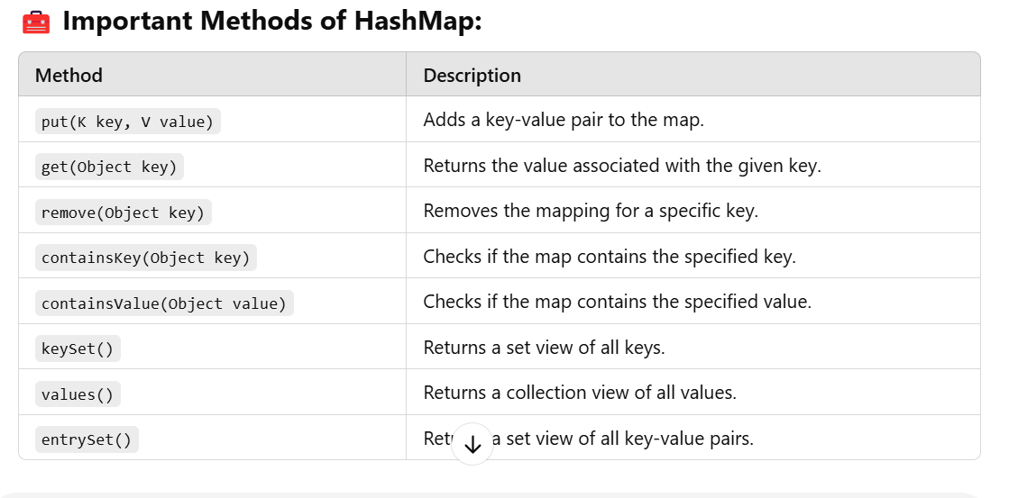

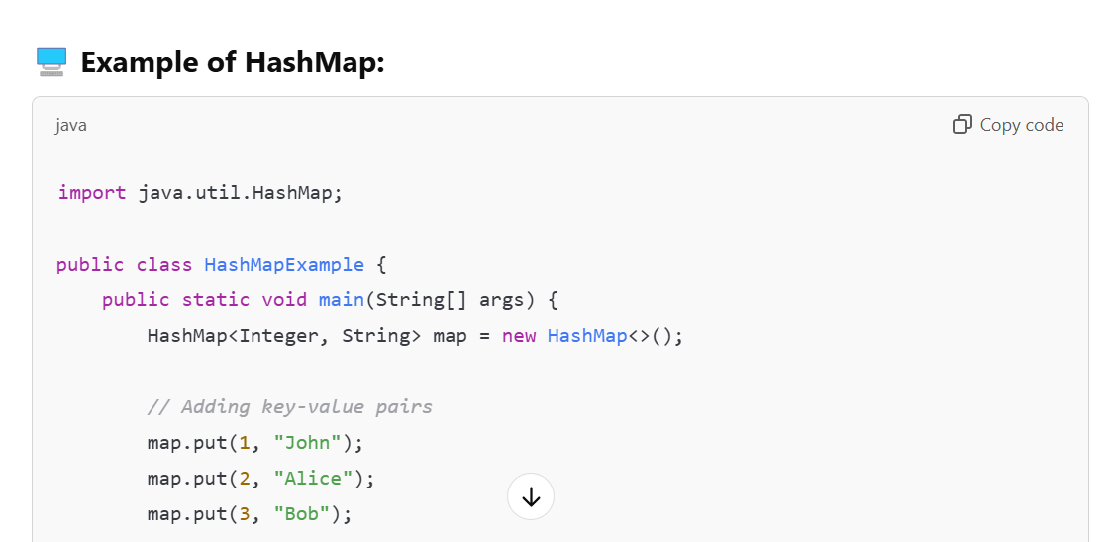

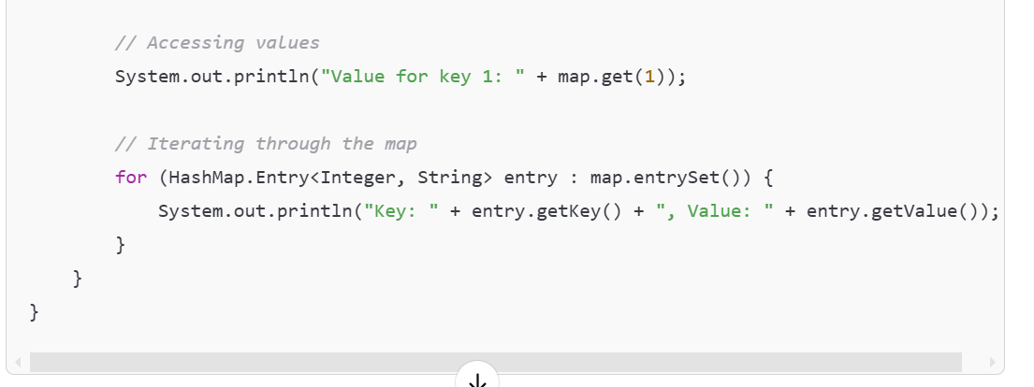

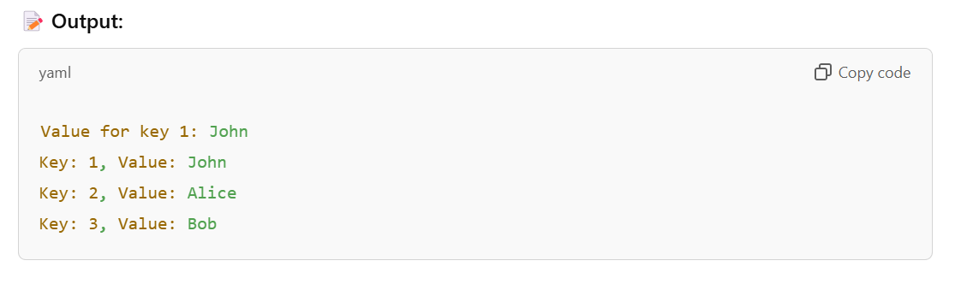

**📚 2. TreeMap in Java**

**🔎 What is TreeMap?**

**TreeMap** is a class that implements the **Map interface** and stores **key-value pairs** in **sorted order** based on the keys. It uses a **Red-Black Tree** internally to maintain the order.

**⚙️ Key Features of TreeMap:**

* **Maintains natural order** (or custom order using a comparator).
* **Does not allow null keys**, but **allows null values**.
* **Thread-safe version available through Collections.synchronizedMap()**.

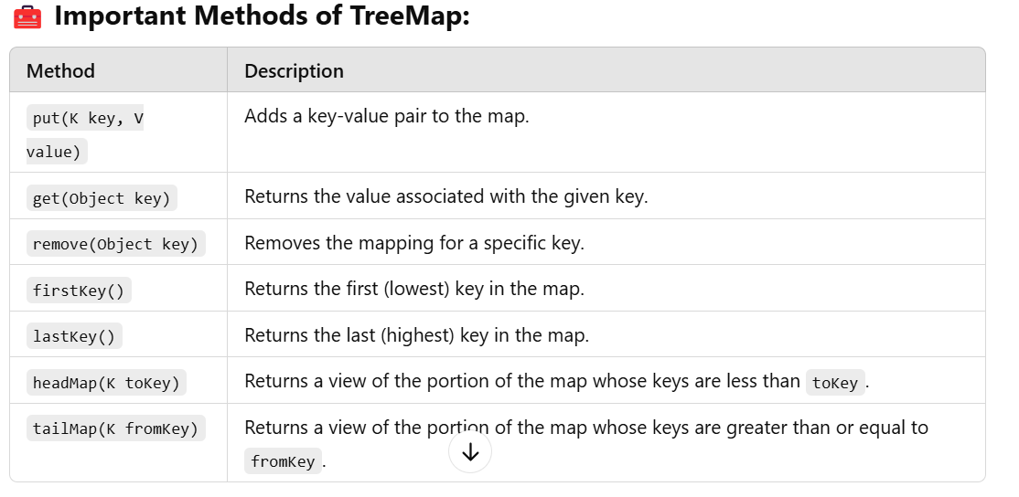

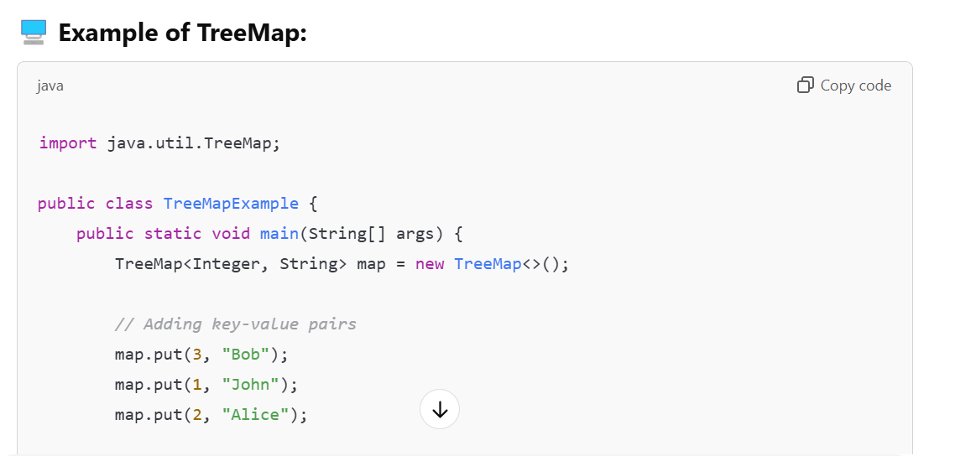

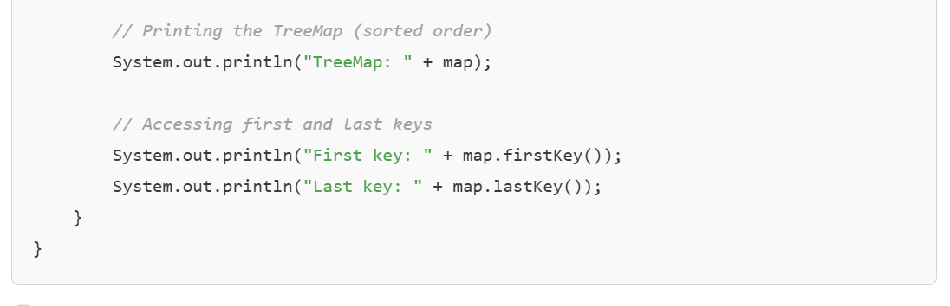

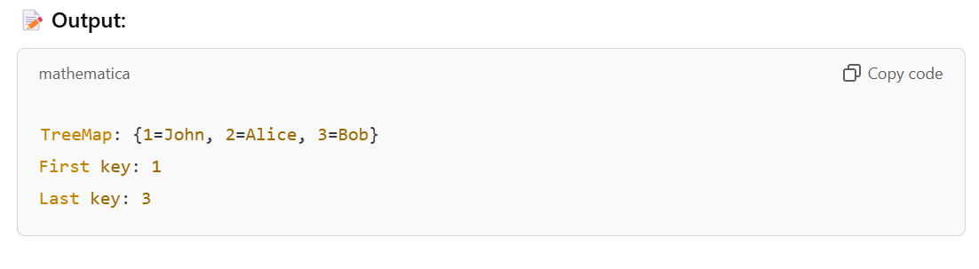

📚 **3. LinkedHashMap in Java**

**🔎 What is LinkedHashMap?**

**LinkedHashMap** is a class that implements the **Map interface** and stores **key-value pairs** while maintaining the **insertion order**.

**⚙️ Key Features of LinkedHashMap:**

* **Maintains insertion order**.
* **Allows one null key** and **multiple null values**.
* **Faster than TreeMap**, but **slower than HashMap**.

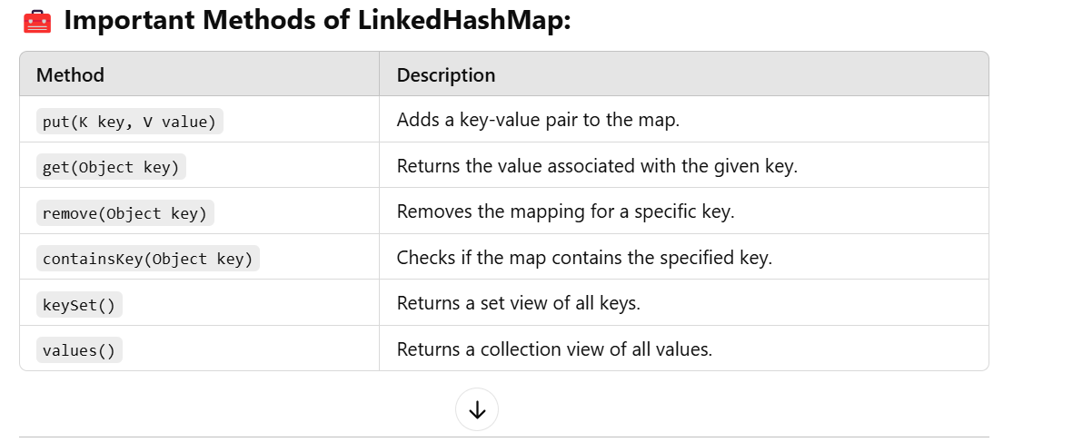

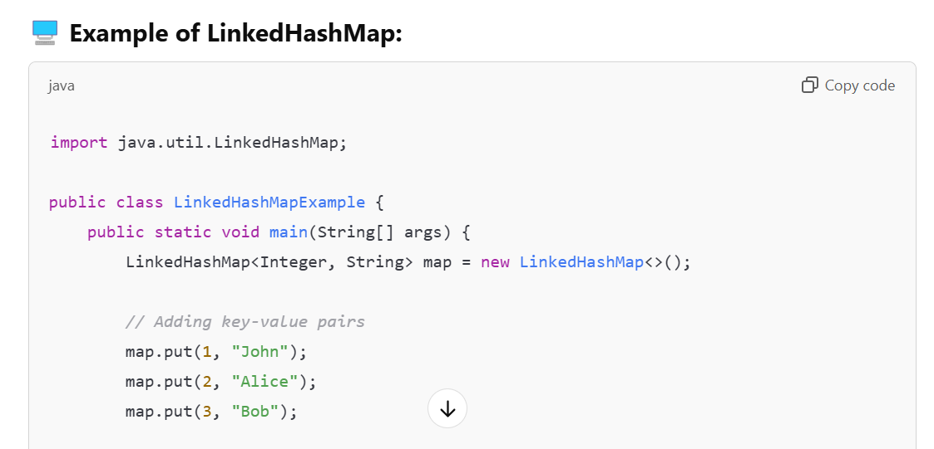 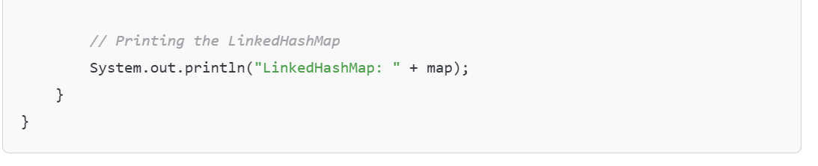

**📚 4. Hashtable in Java**

**🔎 What is Hashtable?**

**Hashtable** is a class that implements the **Map interface** and stores **key-value pairs** in a **synchronized** manner. It is similar to **HashMap**, but it is **thread-safe**.

**⚙️ Key Features of Hashtable:**

* **Thread-safe** (all methods are synchronized).
* **Does not allow null keys or null values**.
* **Slower than HashMap**.

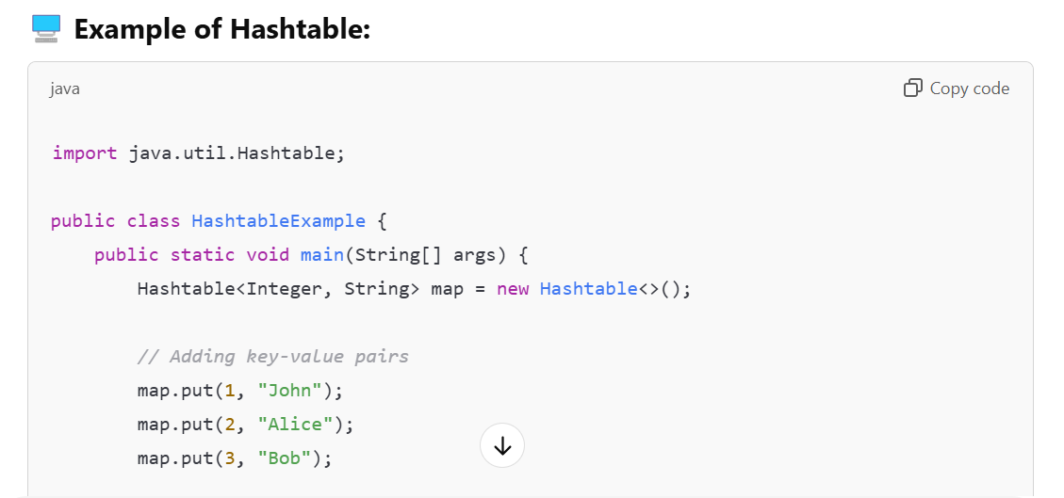

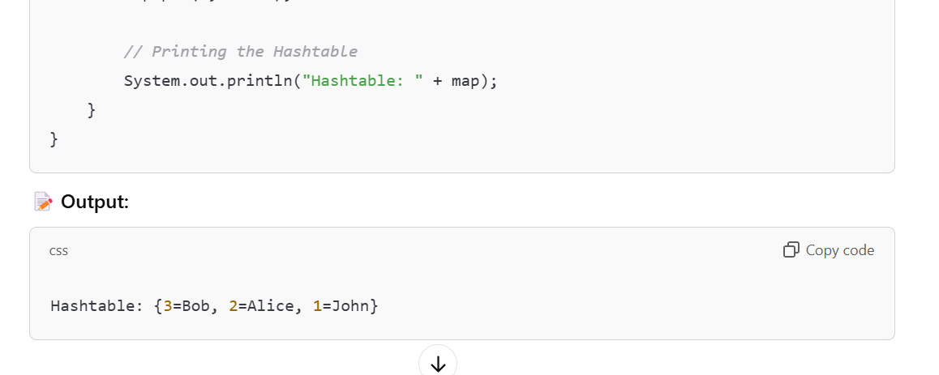

**Java Iterators and Concurrent Collections**

**Iterators in Java**

**Quick Example with Output:**

java

import java.util.ArrayList;

import java.util.Iterator;

import java.util.List;

public class IteratorExample {

public static void main(String[] args) {

*// Create a list*

List<String> programmingLanguages = new ArrayList<>();

programmingLanguages.add("Java");

programmingLanguages.add("Python");

programmingLanguages.add("JavaScript");

programmingLanguages.add("C++");

*// Get an Iterator from the list*

Iterator<String> iterator = programmingLanguages.iterator();

*// Iterate through the list*

System.out.println("Languages:");

while (iterator.hasNext()) {

String language = iterator.next();

System.out.println("- " + language);

*// You can also remove elements while iterating*

*// For example, remove JavaScript*

if (language.equals("JavaScript")) {

iterator.remove();

}

}

*// Print the updated list*

System.out.println("\nList after removal:");

for (String language : programmingLanguages) {

System.out.println("- " + language);

}

}

}

**Output:**

Languages:

- Java

- Python

- JavaScript

- C++

List after removal:

- Java

- Python

- C++

**What is an Iterator?**

* An Iterator is an interface in the Java Collections Framework
* Provides a way to sequentially access elements in a collection
* Located in the java.util package
* Primary purpose: traverse collections without exposing their internal structure

**Iterator Interface Methods**

* **hasNext()**: Returns true if the iteration has more elements
* **next()**: Returns the next element in the iteration
* **remove()**: Removes the last element returned by the iterator (optional operation)
* **forEachRemaining(Consumer<? super E> action)**: Performs the given action for each remaining element

**Basic Usage of Iterator**

java

import java.util.\*;

public class IteratorExample {

public static void main(String[] args) {

List<String> fruits = new ArrayList<>();

fruits.add("Apple");

fruits.add("Banana");

fruits.add("Cherry");

*// Getting Iterator from collection*

Iterator<String> iterator = fruits.iterator();

*// Traversing using Iterator*

System.out.println("Original list:");

while (iterator.hasNext()) {

String fruit = iterator.next();

System.out.println(fruit);

*// Conditionally remove elements*

if (fruit.equals("Banana")) {

iterator.remove(); *// Safe removal during iteration*

}

}

System.out.println("\nList after removal:");

for (String fruit : fruits) {

System.out.println(fruit);

}

}

}

**Output:**

Original list:

Apple

Banana

Cherry

List after removal:

Apple

Cherry

**Advantages of Iterators**

1. **Safe removal**: Can safely remove elements during iteration
2. **Universal access method**: Works with any Collection type
3. **Forward-only traversal**: Simple and efficient
4. **No index needed**: Works with collections that don't support indexed access

**ListIterator (Extended Iterator for Lists)**

* Extends the Iterator interface
* Allows bidirectional traversal (forward and backward)
* Additional methods:
  + **hasPrevious()**: Checks if there are elements in reverse direction
  + **previous()**: Returns the previous element
  + **nextIndex()**: Returns index of the next element
  + **previousIndex()**: Returns index of the previous element
  + **set(E e)**: Replaces the last element returned
  + **add(E e)**: Inserts a new element at the current position

java

ListIterator<String> listIterator = fruits.listIterator();

*// Forward iteration*

System.out.println("Forward iteration:");

while (listIterator.hasNext()) {

System.out.println(listIterator.next());

}

*// Backward iteration*

System.out.println("\nBackward iteration:");

while (listIterator.hasPrevious()) {

System.out.println(listIterator.previous());

}

**Output:**

Forward iteration:

Apple

Cherry

Backward iteration:

Cherry

Apple

**Concurrent Collections**

**Introduction**

* Designed for use in multi-threaded environments
* Provide thread-safe implementations of common collection interfaces
* Part of java.util.concurrent package
* Avoid ConcurrentModificationException issues

**Key Concurrent Collections**

**ConcurrentHashMap**

* Thread-safe version of HashMap
* Allows concurrent reads and a controlled number of concurrent writes
* Better performance than Hashtable or synchronized HashMap

java

*import java.util.concurrent.ConcurrentHashMap;*

*Map<String, Integer> concurrentMap = new ConcurrentHashMap<>();*

*concurrentMap.put("One", 1);*

*concurrentMap.put("Two", 2);*

*// Iterate over the concurrent map*

*System.out.println("ConcurrentHashMap contents:");*

*for (Map.Entry<String, Integer> entry : concurrentMap.entrySet()) {*

*System.out.println(entry.getKey() + " = " + entry.getValue());*

*}*

*/\*\**

*\* Output:*

*\* ConcurrentHashMap contents:*

*\* One = 1*

*\* Two = 2*

*\*/*

**CopyOnWriteArrayList**

* Thread-safe variant of ArrayList
* All mutative operations create a fresh copy of the underlying array
* Ideal for collections that are read frequently but modified infrequently

java

*import java.util.concurrent.CopyOnWriteArrayList;*

*List<String> copyOnWriteList = new CopyOnWriteArrayList<>();*

*copyOnWriteList.add("Item 1");*

*copyOnWriteList.add("Item 2");*

*// Iterate using iterator*

*System.out.println("CopyOnWriteArrayList contents:");*

*Iterator<String> cowIterator = copyOnWriteList.iterator();*

*while (cowIterator.hasNext()) {*

*System.out.println(cowIterator.next());*

*}*

*/\*\**

*\* Output:*

*\* CopyOnWriteArrayList contents:*

*\* Item 1*

*\* Item 2*

*\*/*

**CopyOnWriteArraySet**

* Thread-safe version of Set
* Based on CopyOnWriteArrayList implementation

**ConcurrentLinkedQueue**

* Unbounded thread-safe queue based on linked nodes
* Follows FIFO ordering

java

*import java.util.concurrent.ConcurrentLinkedQueue;*

*Queue<String> concurrentQueue = new ConcurrentLinkedQueue<>();*

*concurrentQueue.offer("First");*

*concurrentQueue.offer("Second");*

*// Iterate through the queue*

*System.out.println("ConcurrentLinkedQueue contents:");*

*Iterator<String> queueIterator = concurrentQueue.iterator();*

*while (queueIterator.hasNext()) {*

*System.out.println(queueIterator.next());*

*}*

*/\*\**

*\* Output:*

*\* ConcurrentLinkedQueue contents:*

*\* First*

*\* Second*

*\*/*

**BlockingQueue Implementations**

* **ArrayBlockingQueue**: Bounded blocking queue backed by an array
* **LinkedBlockingQueue**: Optionally bounded blocking queue based on linked nodes
* **PriorityBlockingQueue**: Unbounded blocking priority queue

java

*import java.util.concurrent.ArrayBlockingQueue;*

*import java.util.concurrent.BlockingQueue;*

*BlockingQueue<String> blockingQueue = new ArrayBlockingQueue<>(10); // Capacity of 10*

*blockingQueue.put("Element 1"); // Blocks if queue is full*

*blockingQueue.put("Element 2");*

*String element = blockingQueue.take(); // Blocks if queue is empty*

*System.out.println("Removed from queue: " + element);*

*System.out.println("Queue after removal:");*

*for (String item : blockingQueue) {*

*System.out.println(item);*

*}*

*/\*\**

*\* Output:*

*\* Removed from queue: Element 1*

*\* Queue after removal:*

*\* Element 2*

*\*/*

**Iterating Concurrent Collections**

When iterating over concurrent collections:

* Iterators are weakly consistent (may reflect changes made after iterator creation)
* No need for external synchronization
* Will not throw ConcurrentModificationException

java

*ConcurrentHashMap<String, Integer> map = new ConcurrentHashMap<>();*

*map.put("One", 1);*

*map.put("Two", 2);*

*map.put("Three", 3);*

*// Safely iterate, even if other threads modify the map*

*System.out.println("Iterating over ConcurrentHashMap:");*

*for (Map.Entry<String, Integer> entry : map.entrySet()) {*

*System.out.println(entry.getKey() + ": " + entry.getValue());*

*// Safe to modify during iteration in ConcurrentHashMap*

*if (entry.getKey().equals("Two")) {*

*map.put("Four", 4); // This won't cause ConcurrentModificationException*

*}*

*}*

*System.out.println("\nMap after modification during iteration:");*

*for (Map.Entry<String, Integer> entry : map.entrySet()) {*

*System.out.println(entry.getKey() + ": " + entry.getValue());*

*}*

*/\*\**

*\* Output:*

*\* Iterating over ConcurrentHashMap:*

*\* One: 1*

*\* Two: 2*

*\* Three: 3*

*\**

*\* Map after modification during iteration:*

*\* One: 1*

*\* Two: 2*

*\* Three: 3*

*\* Four: 4*

*\*/*

**Choosing the Right Concurrent Collection**

1. **Read-heavy workloads**: ConcurrentHashMap, CopyOnWriteArrayList
2. **Write-heavy workloads**: ConcurrentLinkedQueue
3. **Producer-consumer patterns**: BlockingQueue implementations
4. **Need ordering guarantees**: LinkedBlockingQueue, ArrayBlockingQueue

**Comparison: Regular vs. Concurrent Collections**

| **Feature** | **Regular Collections** | **Concurrent Collections** |
| --- | --- | --- |
| Thread Safety | Not thread-safe | Thread-safe |
| Performance in Single Thread | Better | Slightly worse due to synchronization overhead |
| Performance in Multi-Thread | Poor (requires external synchronization) | Good (built-in concurrency control) |
| Iterator Behavior | Fail-fast (throws ConcurrentModificationException) | Weakly consistent (no exceptions) |
| Memory Usage | Lower | Higher (due to additional structures) |

**Common Pitfalls and Best Practices**

**Pitfalls**

1. Using iterator.next() without checking hasNext() first
2. Modifying collections directly during iteration (instead of using iterator.remove())
3. Using regular collections in multi-threaded environments
4. Not considering the performance implications of CopyOnWrite collections for write-heavy workloads

**Best Practices**

1. Always check hasNext() before calling next()
2. Use the appropriate iterator method for removal/modification during iteration
3. Choose the right concurrent collection based on access patterns
4. Consider using stream API for cleaner iteration when modifications aren't needed

**Enhanced For Loop vs. Iterator**

Enhanced for loop (for-each) uses Iterator behind the scenes but:

* Cannot modify the collection (remove elements)
* Cleaner syntax for simple traversal

java

*// Enhanced for loop (uses Iterator internally)*

*System.out.println("Using enhanced for loop:");*

*for (String fruit : fruits) {*

*System.out.println(fruit);*

*// Cannot remove elements here safely*

*}*

*// Explicit Iterator - use when you need to modify during iteration*

*System.out.println("\nUsing explicit Iterator for removal:");*

*Iterator<String> it = fruits.iterator();*

*while (it.hasNext()) {*

*String fruit = it.next();*

*System.out.println("Checking: " + fruit);*

*if (fruit.equals("Cherry")) {*

*it.remove(); // Safe removal*

*System.out.println("Removed Cherry");*

*}*

*}*

*System.out.println("\nFinal list:");*

*for (String fruit : fruits) {*

*System.out.println(fruit);*

*}*

*/\*\**

*\* Output:*

*\* Using enhanced for loop:*

*\* Apple*

*\* Cherry*

*\**

*\* Using explicit Iterator for removal:*

*\* Checking: Apple*

*\* Checking: Cherry*

*\* Removed Cherry*

*\**

*\* Final list:*

*\* Apple*

*\*/*

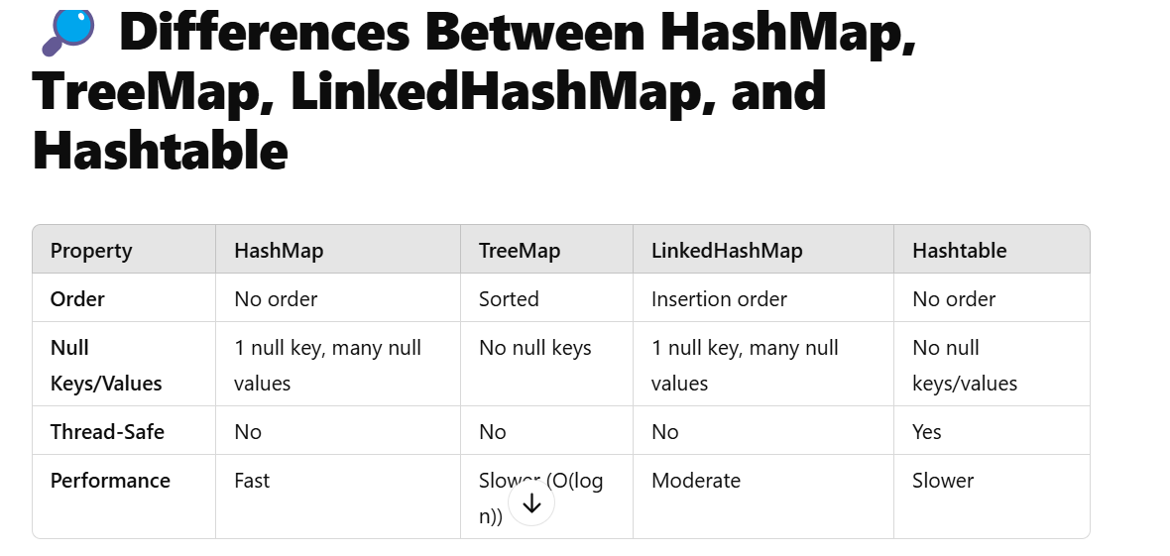

**Question: String = "This is a great thing" count the occur ace of the character and word in**

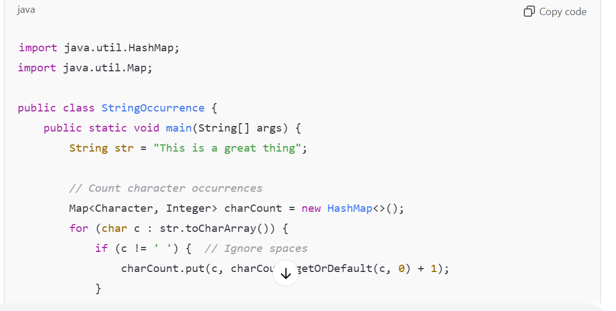

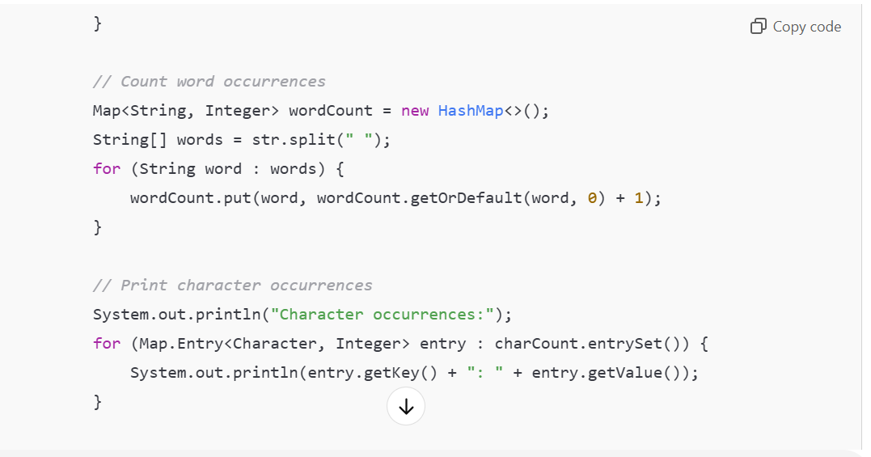

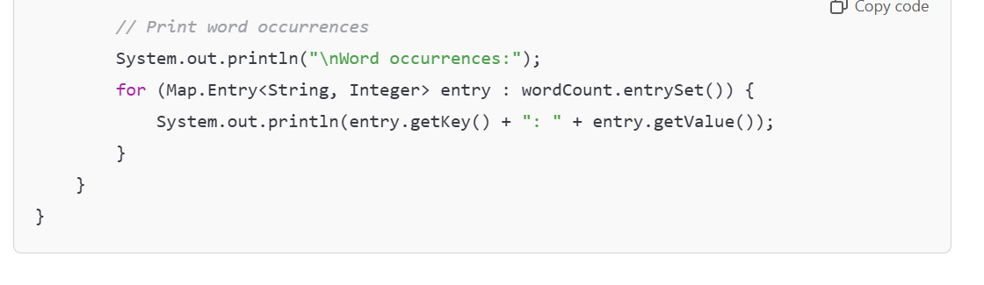

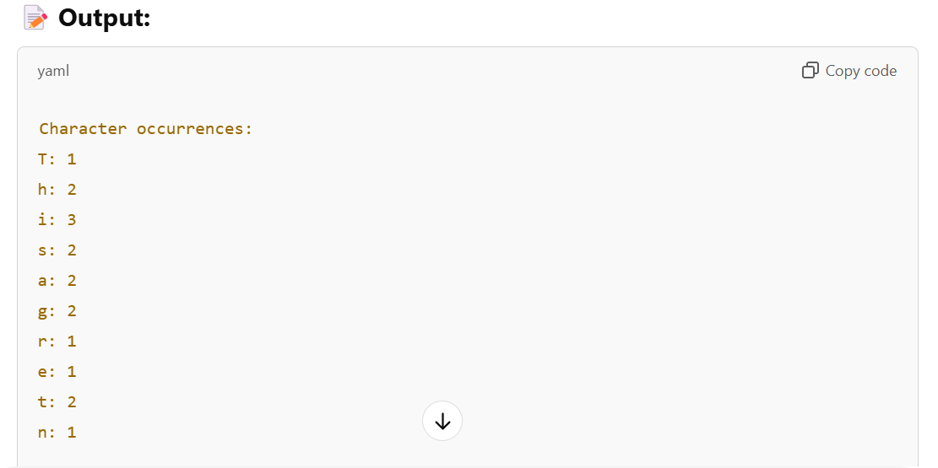 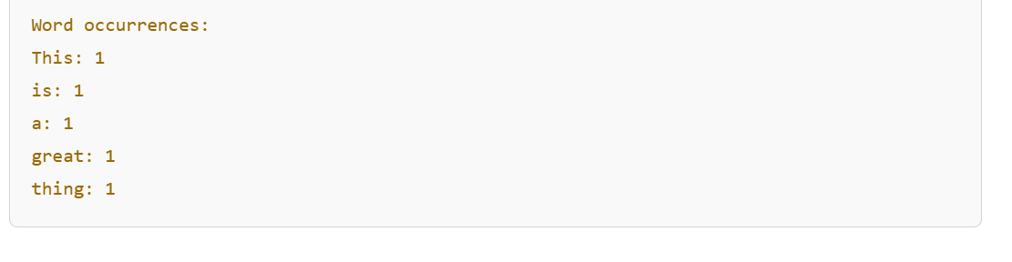

**🔎 Explanation:**

1. **Character Count Logic:**
   * Convert the string to a **character array** using toCharArray().
   * Use a **HashMap** to store each character as a key and its occurrence as a value.
   * Skip spaces while counting.
2. **Word Count Logic:**
   * Split the string into **words** using split(" ").
   * Use a **HashMap** to store each word as a key and its occurrence as a value.

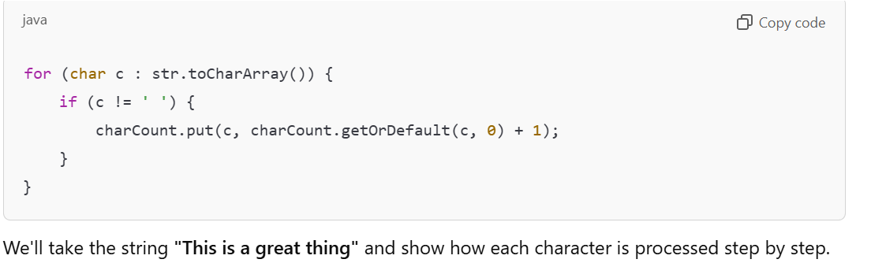

**🔎 What is getOrDefault() Method?**

The **getOrDefault()** method is used with a **Map** (like **HashMap**, **TreeMap**, etc.) to **retrieve the value associated with a given key**. If the key is **not present** in the map, it returns a **default value** that you specify.

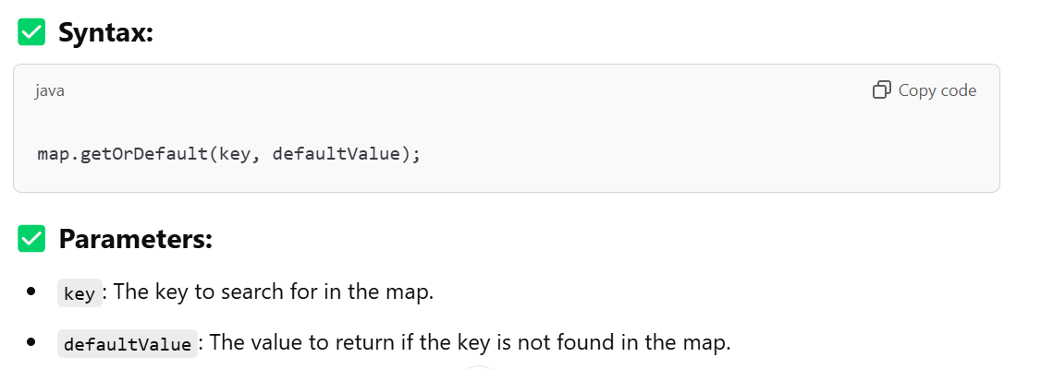

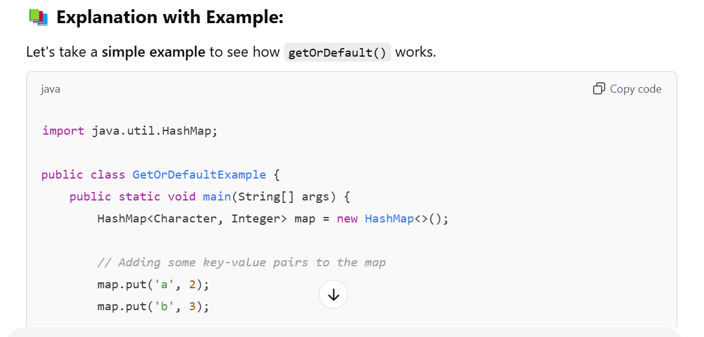

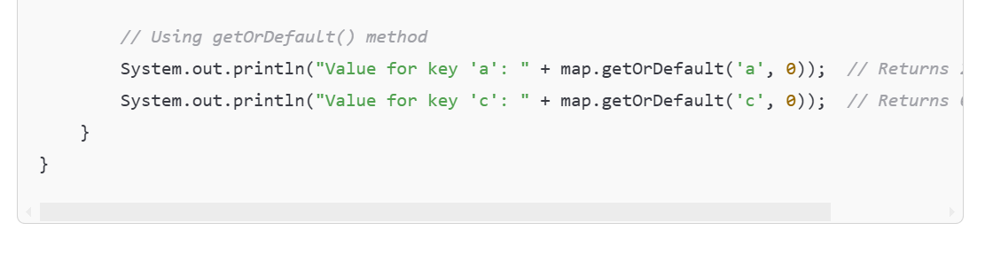

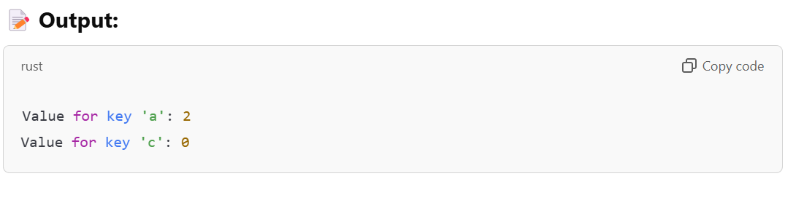

**🔧 How It Works:**

1. **map.getOrDefault('a', 0)**:
   * The key **'a'** exists in the map with a value of **2**.
   * So, it returns **2**.
2. **map.getOrDefault('c', 0)**:
   * The key **'c'** does **not exist** in the map.
   * So, it returns the **default value** of **0**.

**🔎 Initial Setup:**

* Input string: **"This is a great thing"**
* **charCount** is an empty HashMap at the start:  
  charCount = {}

**🎯 Dry Run:**

Let's go through each character in the string:

**✅ Iteration 1:**

* **Character:** 'T'
* Check if 'T' is a space:  
  **No**, so we continue.
* **charCount.getOrDefault('T', 0)** returns **0** (since 'T' is not in the map).
* Add 'T' with a count of **1**.

**charCount after this iteration:**

{T=1}

**✅ Iteration 2:**

* **Character:** 'h'
* Check if 'h' is a space:  
  **No**, so we continue.
* **charCount.getOrDefault('h', 0)** returns **0**.
* Add 'h' with a count of **1**.

**charCount after this iteration:**

r

Copy code

{T=1, h=1}

**✅ Iteration 3:**

* **Character:** 'i'
* Check if 'i' is a space:  
  **No**, so we continue.
* **charCount.getOrDefault('i', 0)** returns **0**.
* Add 'i' with a count of **1**.

**charCount after this iteration:**

css

Copy code

{T=1, h=1, i=1}

**✅ Iteration 4:**

* **Character:** 's'
* Check if 's' is a space:  
  **No**, so we continue.
* **charCount.getOrDefault('s', 0)** returns **0**.
* Add 's' with a count of **1**.

**charCount after this iteration:**

css

Copy code

{T=1, h=1, i=1, s=1}

**✅ Iteration 5:**

* **Character:** ' ' (space)
* Check if ' ' is a space:  
  **Yes**, so **skip this character**.

**charCount remains the same:**

css

Copy code

{T=1, h=1, i=1, s=1}

**✅ Iteration 6:**

* **Character:** 'i'
* Check if 'i' is a space:  
  **No**, so we continue.
* **charCount.getOrDefault('i', 0)** returns **1** (since 'i' is already in the map).
* Increment the count of 'i' to **2**.

**charCount after this iteration:**

css

Copy code

{T=1, h=1, i=2, s=1}

**✅ Iteration 7:**

* **Character:** 's'
* Check if 's' is a space:  
  **No**, so we continue.
* **charCount.getOrDefault('s', 0)** returns **1** (since 's' is already in the map).
* Increment the count of 's' to **2**.

**charCount after this iteration:**

css

Copy code

{T=1, h=1, i=2, s=2}

**✅ Iteration 8:**

* **Character:** ' ' (space)
* Check if ' ' is a space:  
  **Yes**, so **skip this character**.

**charCount remains the same:**

css

Copy code

{T=1, h=1, i=2, s=2}

**✅ Continue with Remaining Characters...**

Following the same logic, here’s how the **charCount** map will be updated after processing all characters:

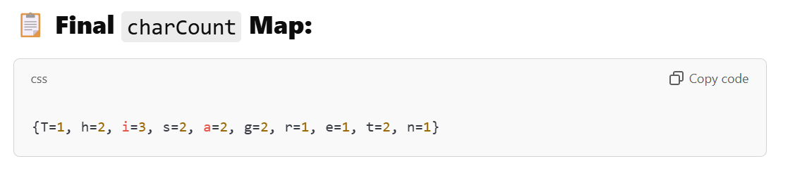

**🔄 Step 2: Word Count Dry Run**

**🎯 Words Split from String:**

css

Copy code

["This", "is", "a", "great", "thing"]

**🎯 Word Loop:**

**➡️ Iteration 1:**

* **Word:** "This"
* **wordCount:** { "This" -> 1 }

**➡️ Iteration 2:**

* **Word:** "is"
* **wordCount:** { "This" -> 1, "is" -> 1 }

**➡️ Iteration 3:**

* **Word:** "a"
* **wordCount:** { "This" -> 1, "is" -> 1, "a" -> 1 }

**➡️ Iteration 4:**

* **Word:** "great"
* **wordCount:** { "This" -> 1, "is" -> 1, "a" -> 1, "great" -> 1 }

**➡️ Iteration 5:**

* **Word:** "thing"
* **wordCount:** { "This" -> 1, "is" -> 1, "a" -> 1, "great" -> 1, "thing" -> 1 }

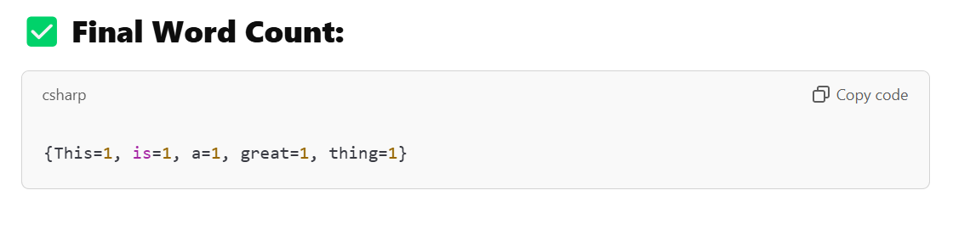

**How to Recognize Patterns in Array Problems**

Understanding patterns is the key to solving array problems efficiently. Here's how to recognize and apply these patterns:

**1. Two Pointers Pattern**

**When to Use:**

* When you need to process elements in a sequence while comparing or tracking positions
* Often used in **sorted arrays** or when you need to find pairs
* Problems involving **partitioning** or **subarrays**

**Common Problems:**

1. Pair with Target Sum (Two Sum)
2. Remove Duplicates from Sorted Array
3. Triplets that Sum to Zero

**How to Identify:**

* Look for problems where you need to **find pairs** or **compare elements at different positions**
* The problem mentions **"sorted array"** or **"pair of elements"**

**Example Thought Process:**

1. Initialize two pointers (start=0, end=length-1)
2. Move them based on conditions (e.g., sum too low → move start++, sum too high → move end--)

**2. Sliding Window Pattern**

**When to Use:**

* When you need to find **contiguous subarrays/substrings** under certain conditions
* Problems involving **"longest"**, **"shortest"**, or **"fixed-size"** windows
* Often used with **strings** or **arrays**

**Common Problems:**

1. Maximum Sum Subarray of Size K
2. Longest Substring Without Repeating Characters
3. Minimum Size Subarray Sum

**How to Identify:**

* Keywords: **"subarray"**, **"contiguous"**, **"window"**
* The problem asks for **maximum/minimum length or sum** in a sequence

**Example Thought Process:**

1. Initialize windowStart = 0 and windowSum = 0
2. Loop through the array with windowEnd:
   * Add elements to windowSum
   * If condition is violated, shrink the window (windowStart++)

**3. Kadane's Algorithm (Maximum Subarray)**

**When to Use:**

* When you need to find **a contiguous subarray with the largest sum**
* Works with **positive and negative numbers**
* Problems involving **maximum/minimum sum subarrays**

**Common Problems:**

1. Maximum Subarray (Classic Kadane's)
2. Maximum Sum Circular Subarray
3. Maximum Product Subarray

**How to Identify:**

* Keywords: **"maximum sum"**, **"contiguous subarray"**
* The problem involves **finding the best possible segment** in an array

**Example Thought Process:**

1. Initialize currentMax = nums[0] and globalMax = nums[0]
2. For each element:
   * currentMax = max(nums[i], currentMax + nums[i])
   * globalMax = max(globalMax, currentMax)

**4. Fast & Slow Pointers (Floyd's Algorithm)**

**When to Use:**

* When you need to detect **cycles** in a linked list or array
* Problems involving **middle of a list** or **cyclic dependencies**

**Common Problems:**

1. Linked List Cycle Detection
2. Find the Middle of a Linked List
3. Happy Number Problem

**How to Identify:**

* Keywords: **"cycle"**, **"loop"**, **"middle element"**
* The problem involves **traversal with different speeds**

**Example Thought Process:**

1. Initialize slow = head, fast = head
2. Move slow by 1 step, fast by 2 steps
3. If they meet → cycle exists

**5. Prefix Sum (Cumulative Sum)**

**When to Use:**

* When you need **range sum queries** or **subarray sums**
* Problems involving **equilibrium index** or **subarray averages**

**Common Problems:**

1. Subarray Sum Equals K
2. Find Pivot Index
3. Range Sum Query (Immutable Array)

**How to Identify:**

* Keywords: **"sum of subarray"**, **"range queries"**
* The problem asks for **sums between indices**

**Example Thought Process:**

1. Compute prefixSum[] where prefixSum[i] = sum(nums[0..i])
2. To get sum between i and j: prefixSum[j] - prefixSum[i-1]

**How to Practice Pattern Recognition?**

1. **Solve Problems by Category**
   * Pick a pattern (e.g., Sliding Window) and solve 5-10 problems on it.
   * Example: [LeetCode Sliding Window Problems](https://leetcode.com/tag/sliding-window/" \t "_blank)
2. **Compare Similar Problems**
   * After solving, ask:
     + How was this similar to another problem?
     + What was the key insight?
3. **Draw It Out**
   * Sketch how pointers move in **Two Pointers**
   * Visualize window resizing in **Sliding Window**
4. **Modify Problems**
   * Take a problem you solved and tweak it:
     + "What if the array was circular?"
     + "What if I need the smallest window instead of largest?"